Introduction

Gradient Descent

when to use deep learning

MMSE

Decision Theory

MAP

ML

Entropy

Regulatization

Train/Test Split

Simple DNN

Forward Propagation

Back Propagation

idea

summary

regularizer

Multi-Layer Perceptron

A Big Picture

Activation Function

Cost Function

Optimizer

Regularization

Dropout

Normalization

Dimensionality Reduction

PCA

LDA

Hyper parameter

Universal Approximation Theorem

CNN

Introduction

Kernel(Filter)

Conv layer

Pooling layer

De-Conv(Transpose convolution) layer

Transposed 2D convolution with no padding, stride of 2 and kernel of 3

Group Convolution

Seperable Convolutions

Full Connect layer

# of Parameters computation

Visualization

Different Nets

LeNet(1998)

AlexNet(2012)

VGG

Resnet

GoogleNet (Inception)

MobileNet

Coding

Keras

RNN

TensorFlow and Keras

sequential model

Pytorch

**EE599 Deep Learning**

**Introduction**

**Gradient Descent**

Steepest Gradient Descent



Stochastic Gradient Descent

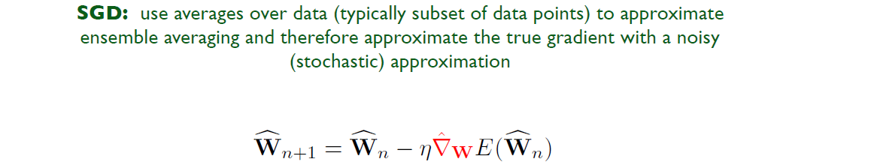

single point stochastic gradient descent

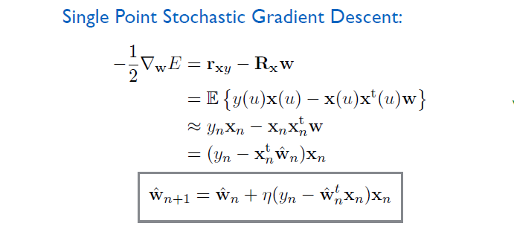

**when to use deep learning**

Don't

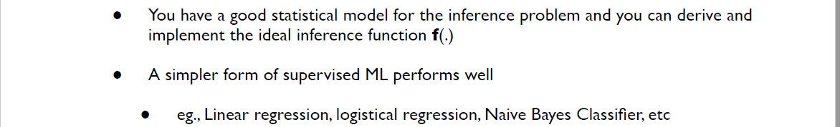

Do

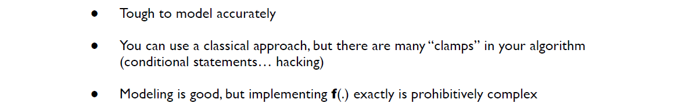

**MMSE**

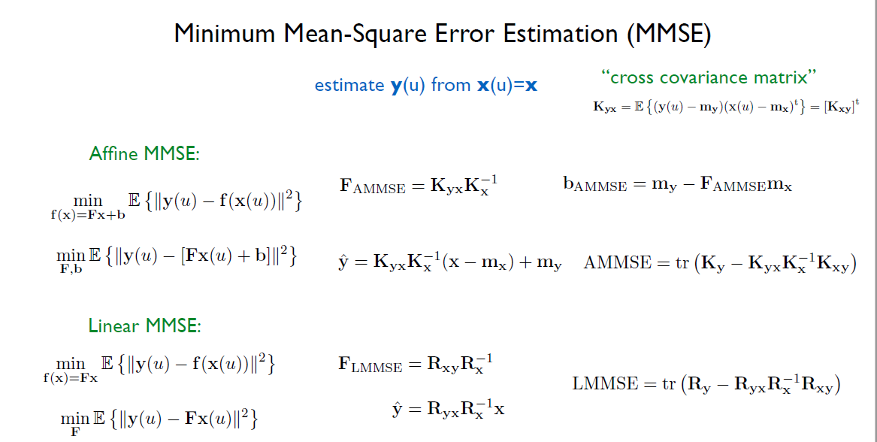

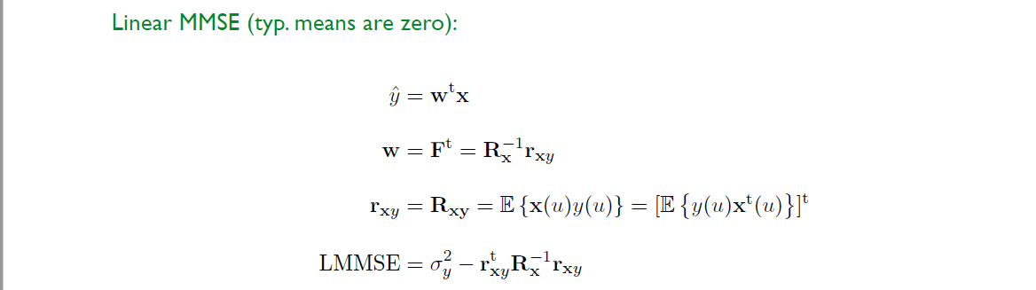

**Decision Theory**

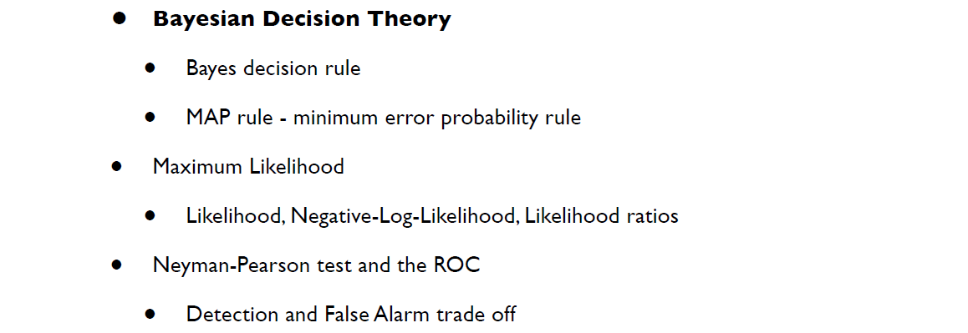

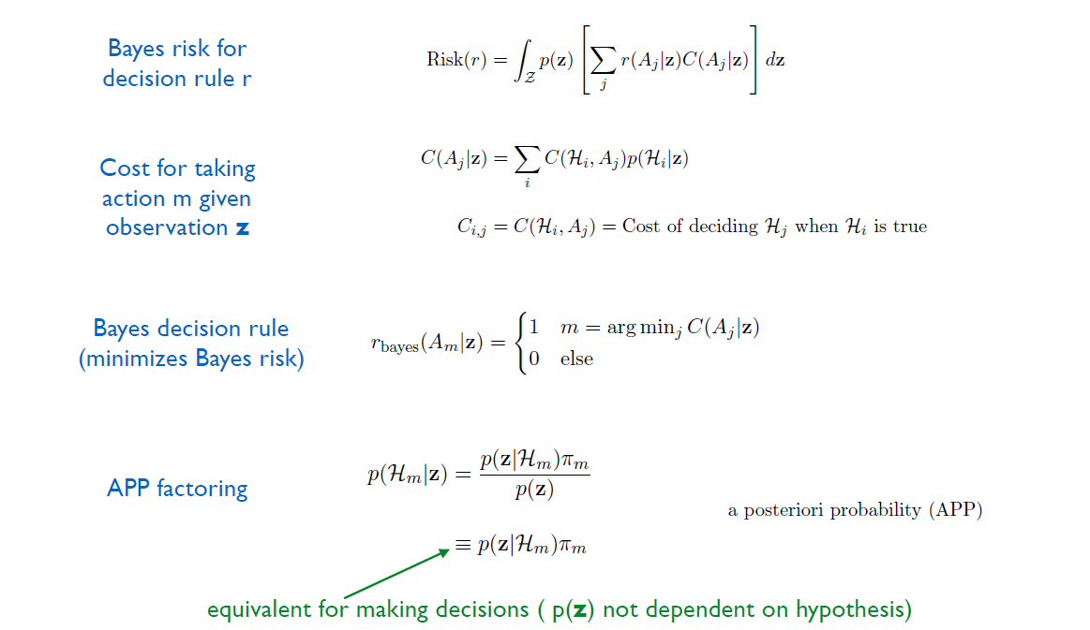

**MAP**

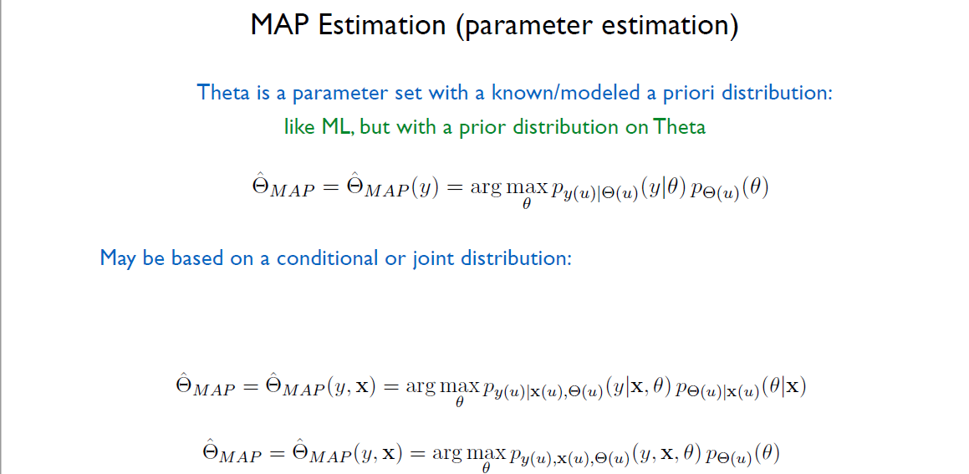

**ML**

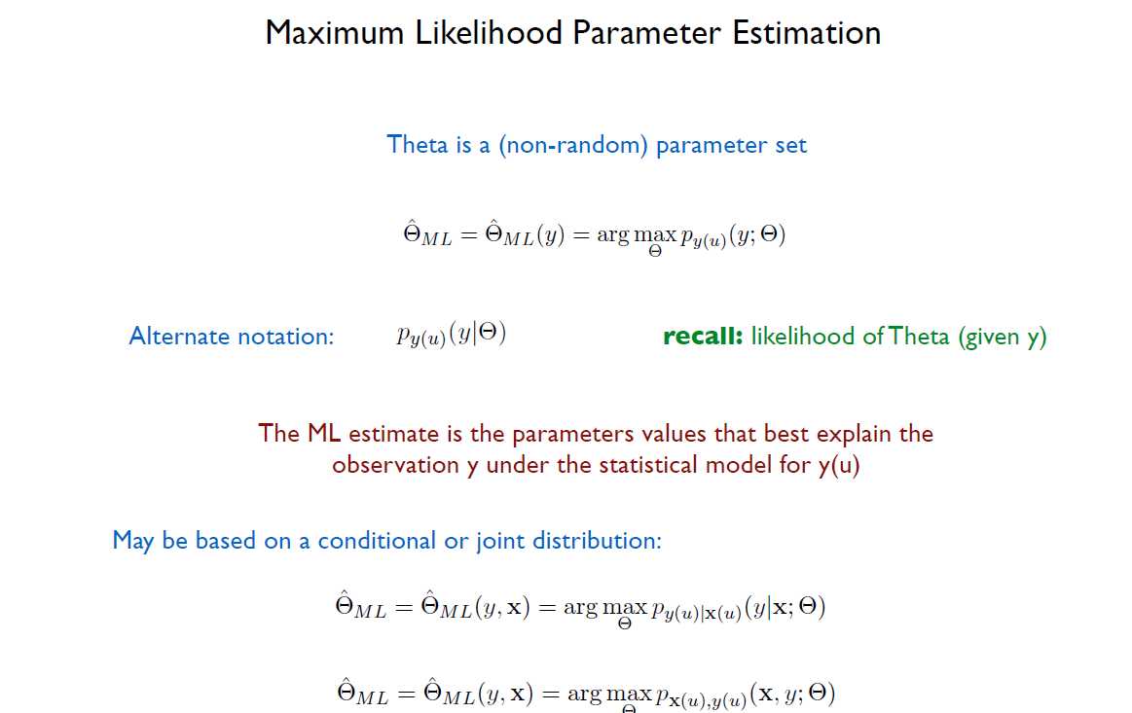

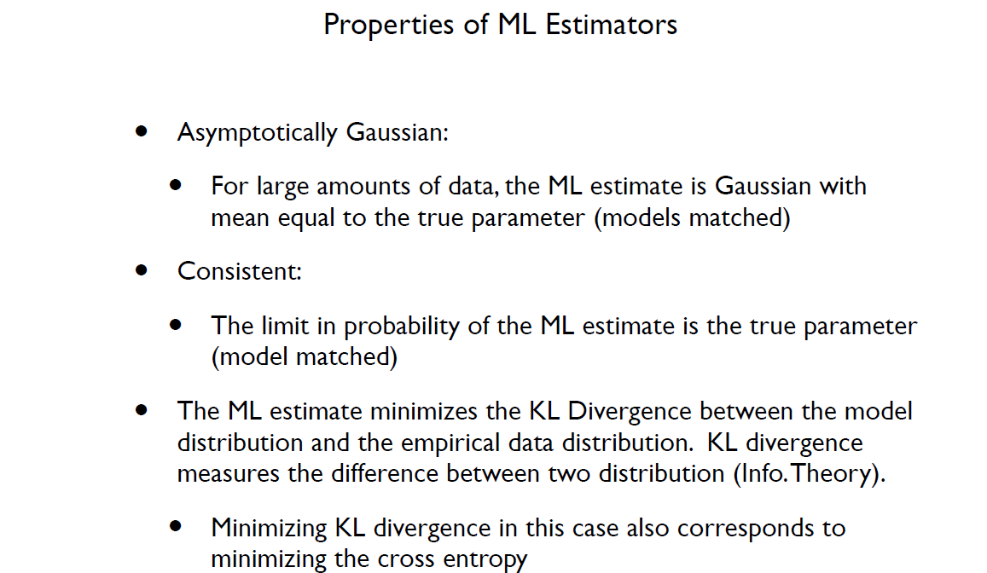

**Entropy**

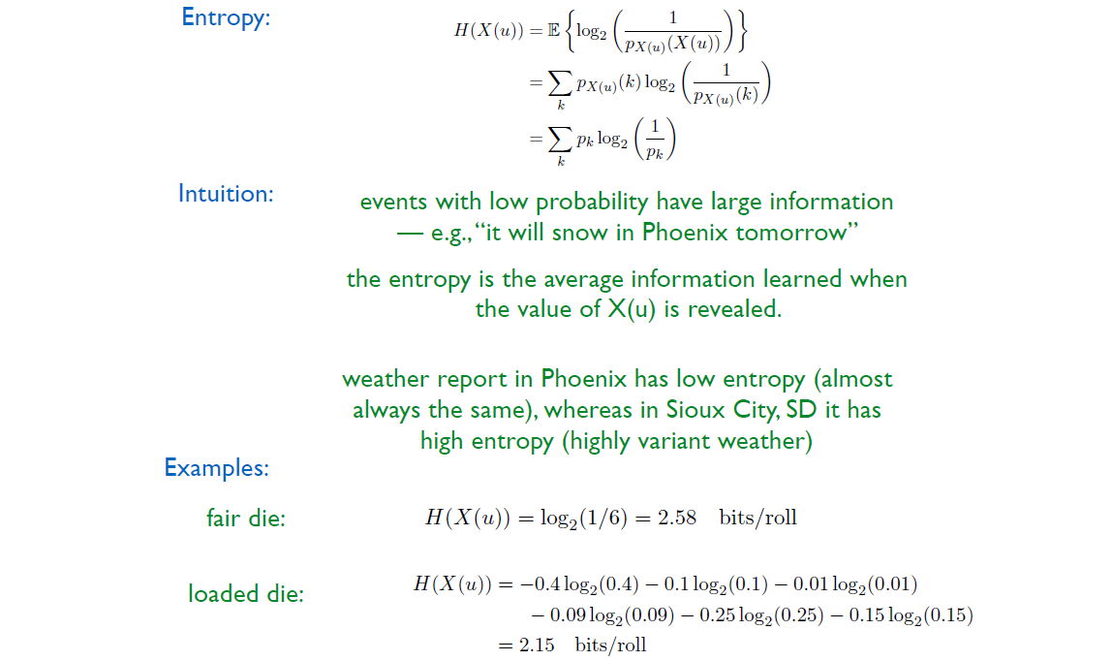

**cross entropy**



**binary cross entropy**

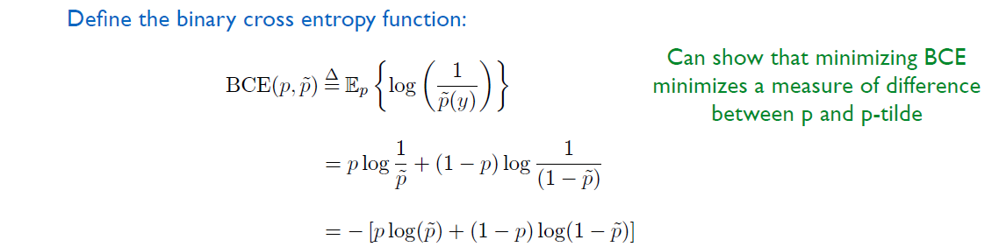

**Regulatization**

enforce penalty on weights to bias toward a prior distribution. --> to reduce over-fitting (by smaller weight)

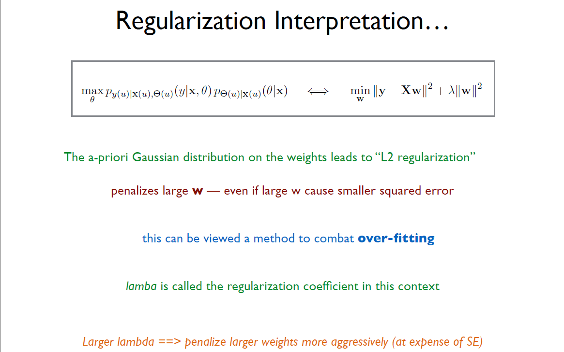

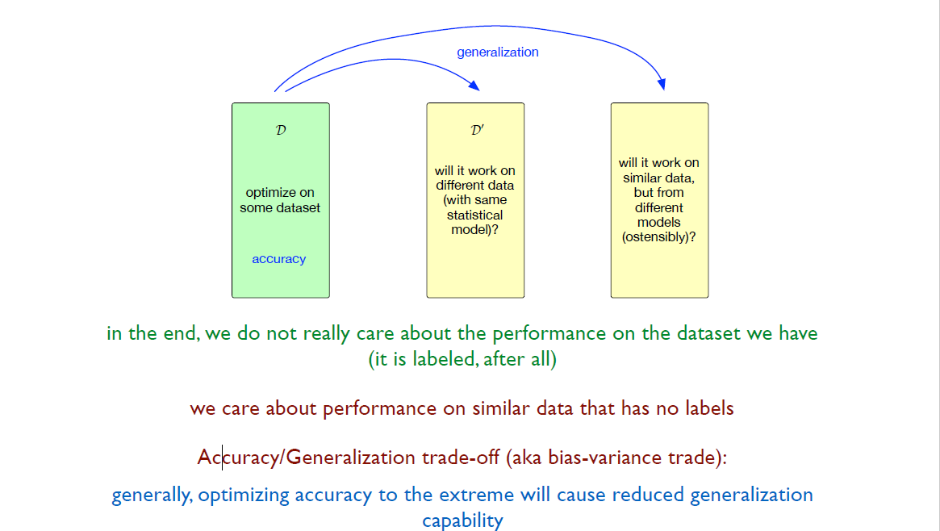

**Train/Test Split**

Training Set -- for define trainable parameters

Validation Set -- for define hyper-parameters

Test Set -- for verify model performance

Mini- Batch -- for do one SGD update per mini-batch

epoch -- one training run through all data set

iteration -- number of mini-batches per epoch

**Simple DNN**

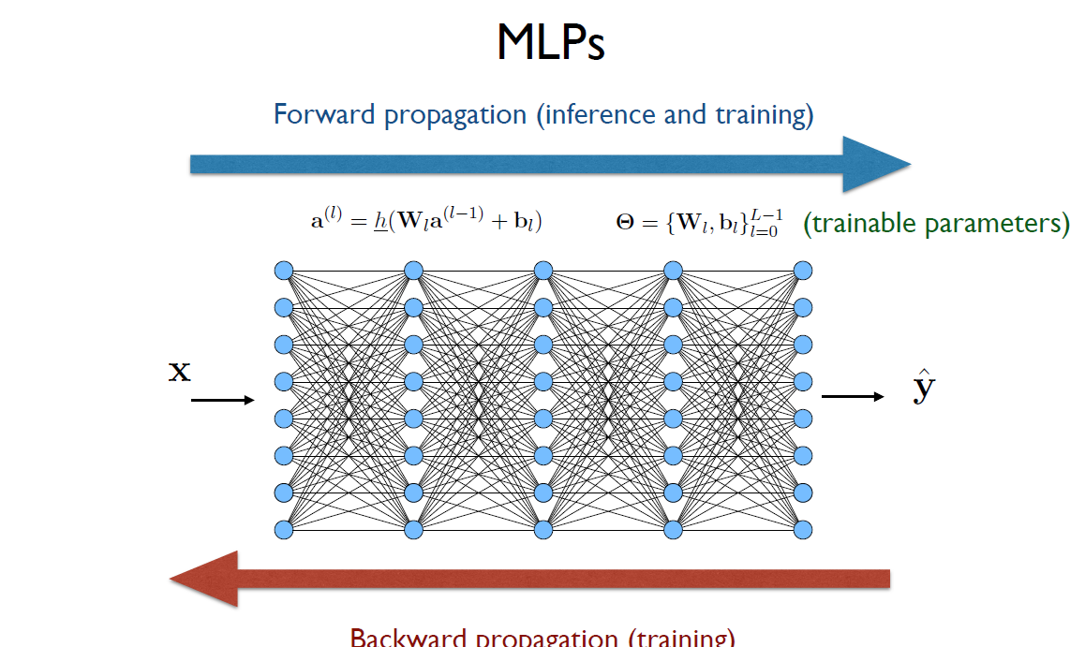

**Forward Propagation**

**Back Propagation**

**idea**

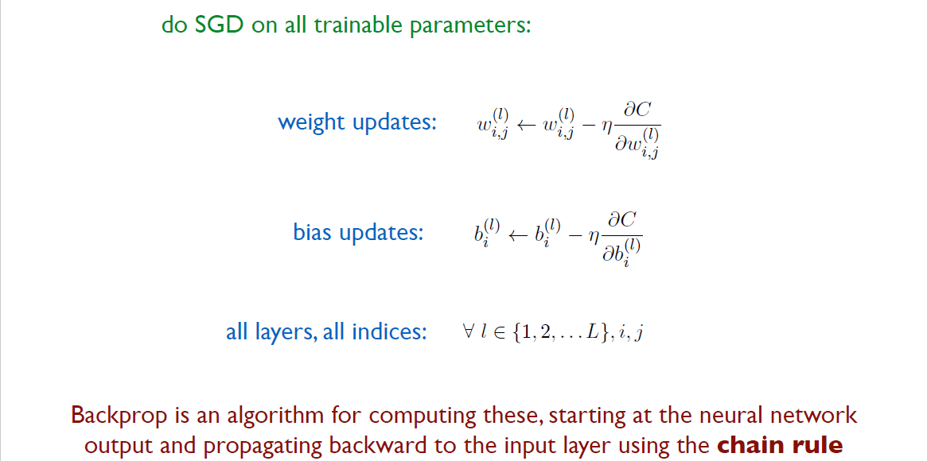

To be specified, one step of forward neural net can be extracted as follow:

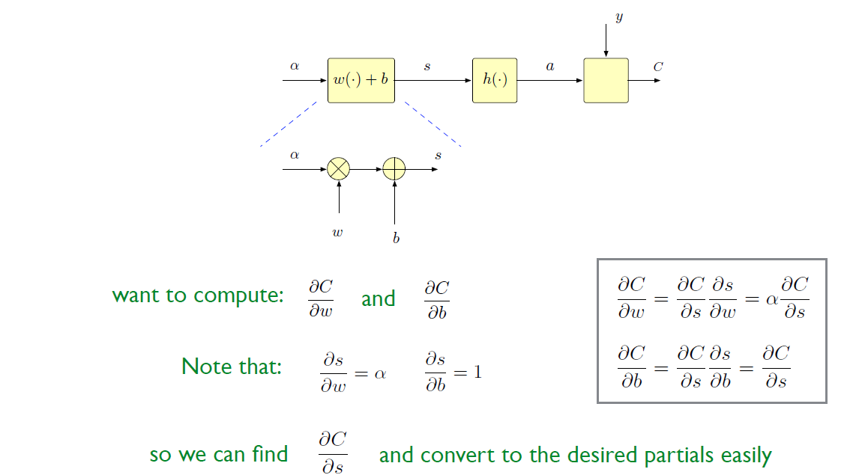

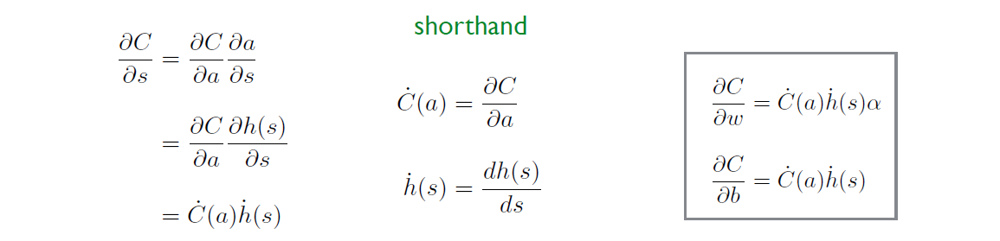

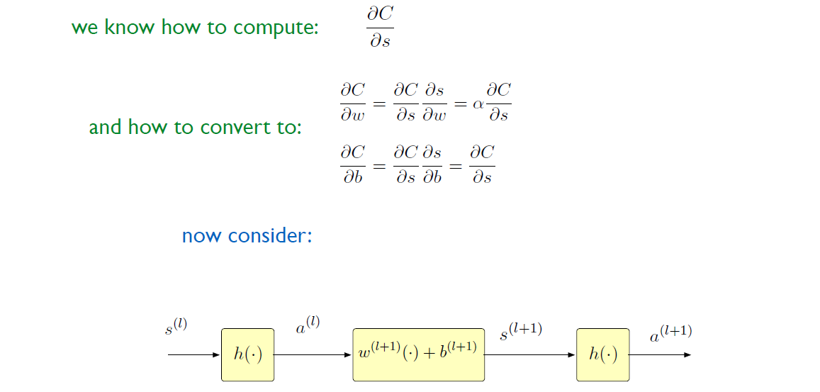

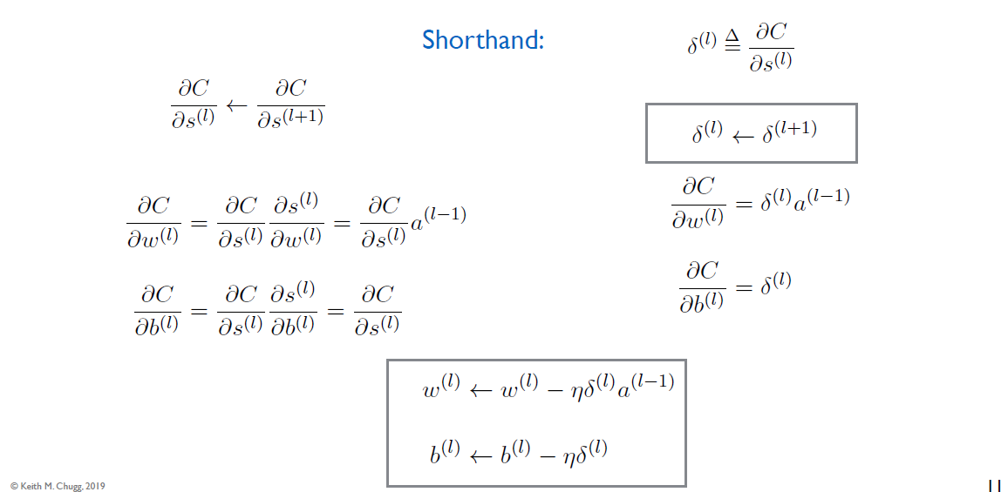

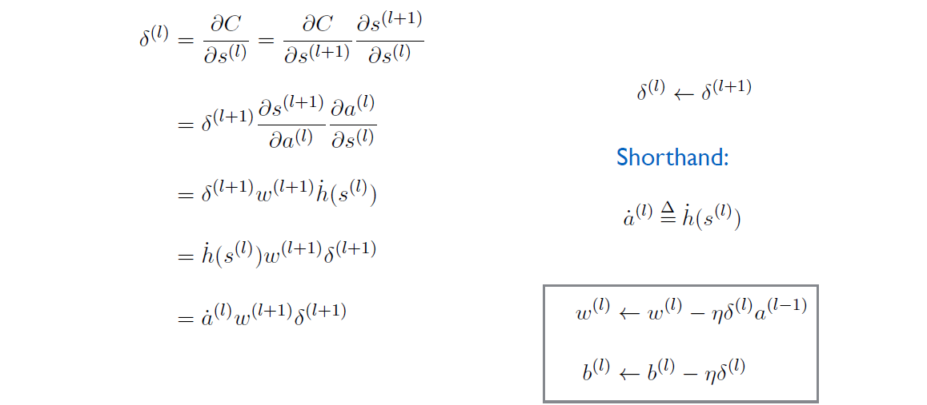



work for matrix (vector case)

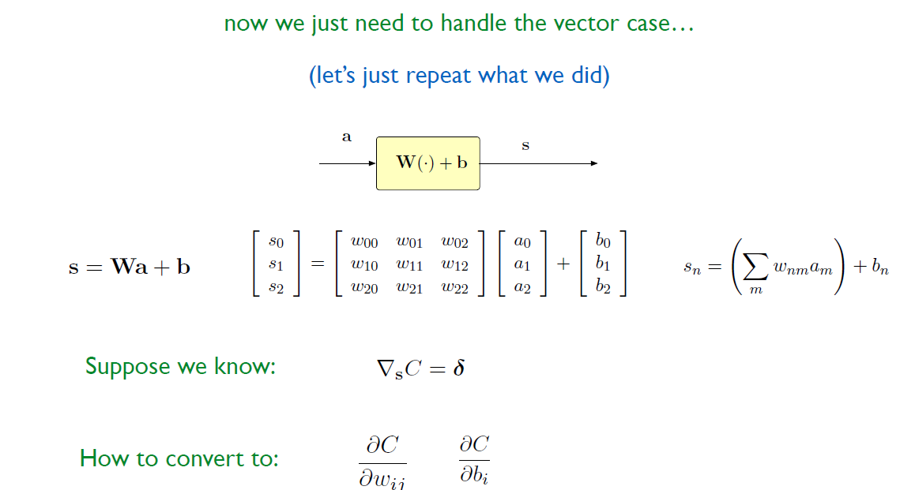

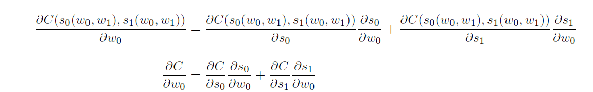

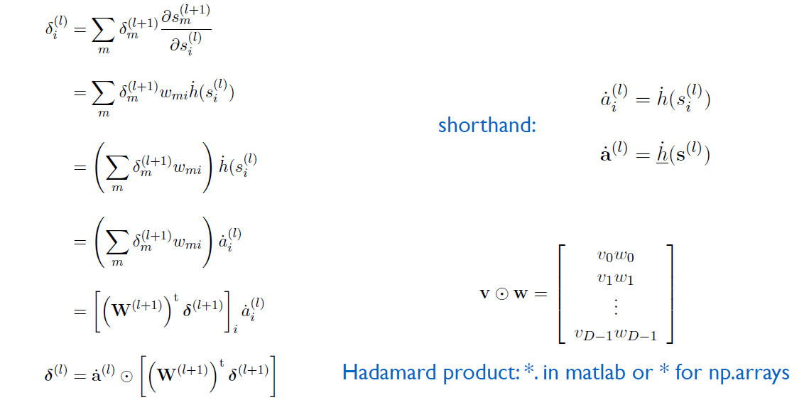

**summary**

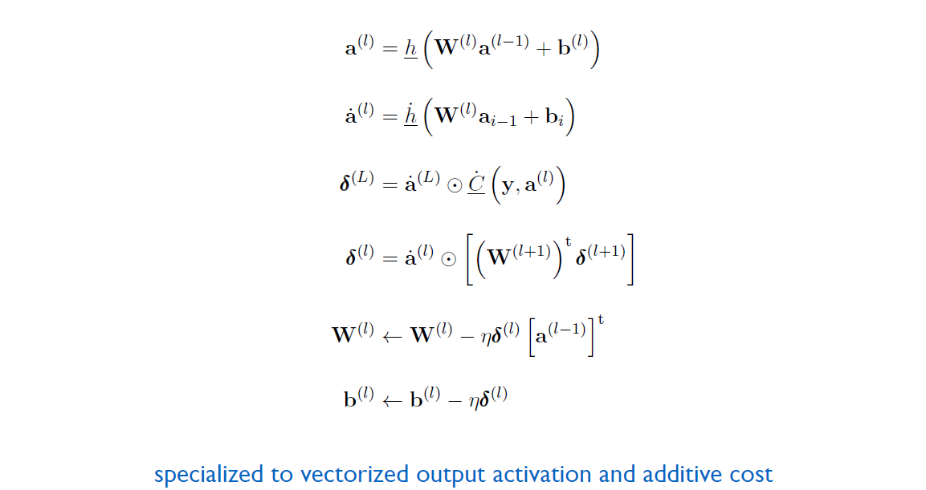

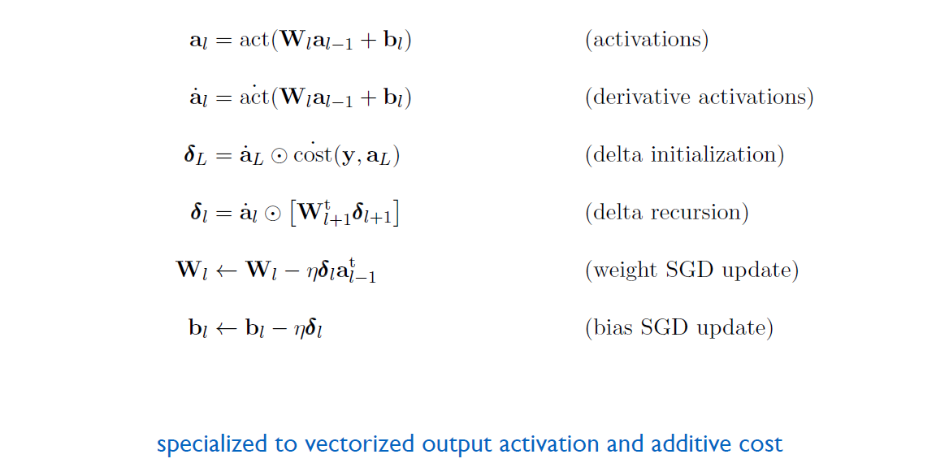

**using batch**

so it's like compute several data points with same **w** and **δ** and use average as the update delta

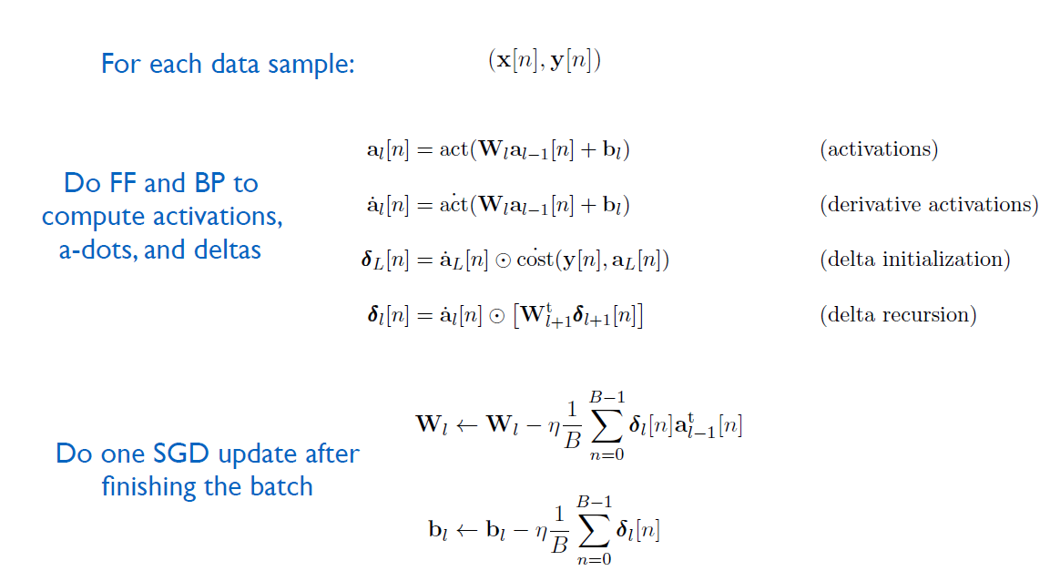

**regularizer**

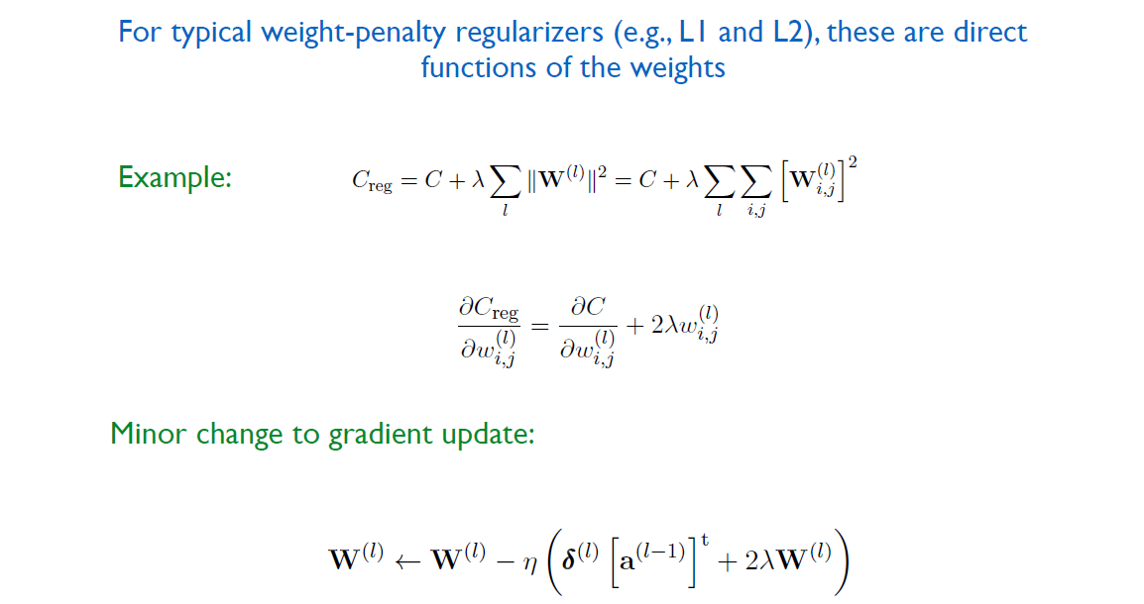

**Multi-Layer Perceptron**

**A Big Picture**

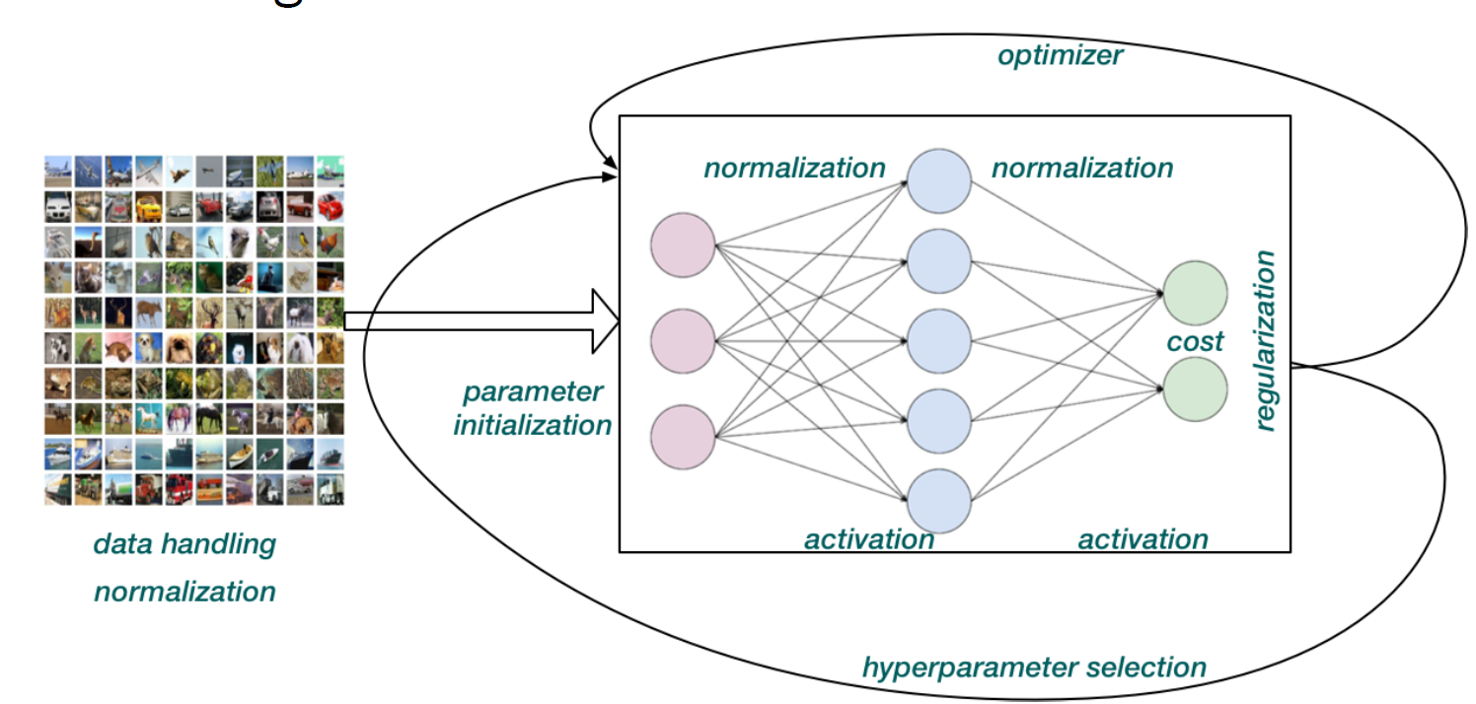

**Activation Function**

**middle layers Activation Function**

sigmoid & tanh

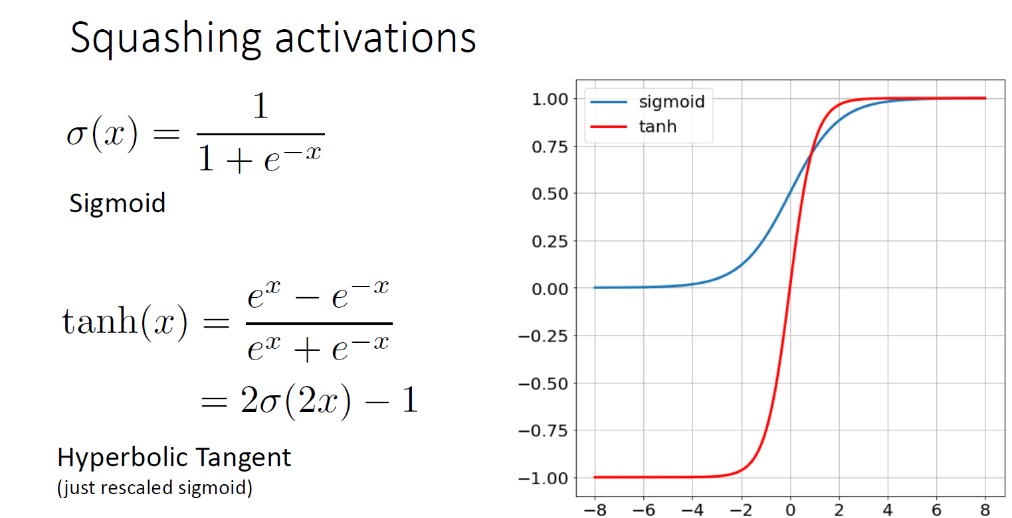

problem: vanish

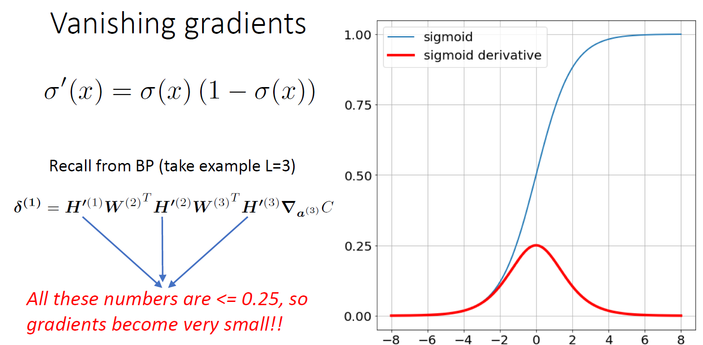

more important: **ReLU family -- will not vanish**

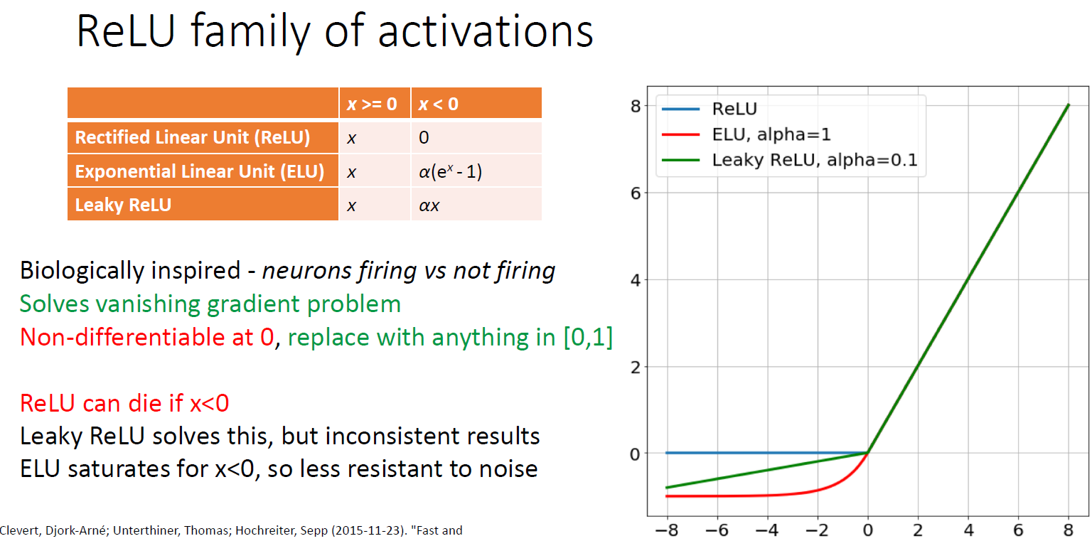

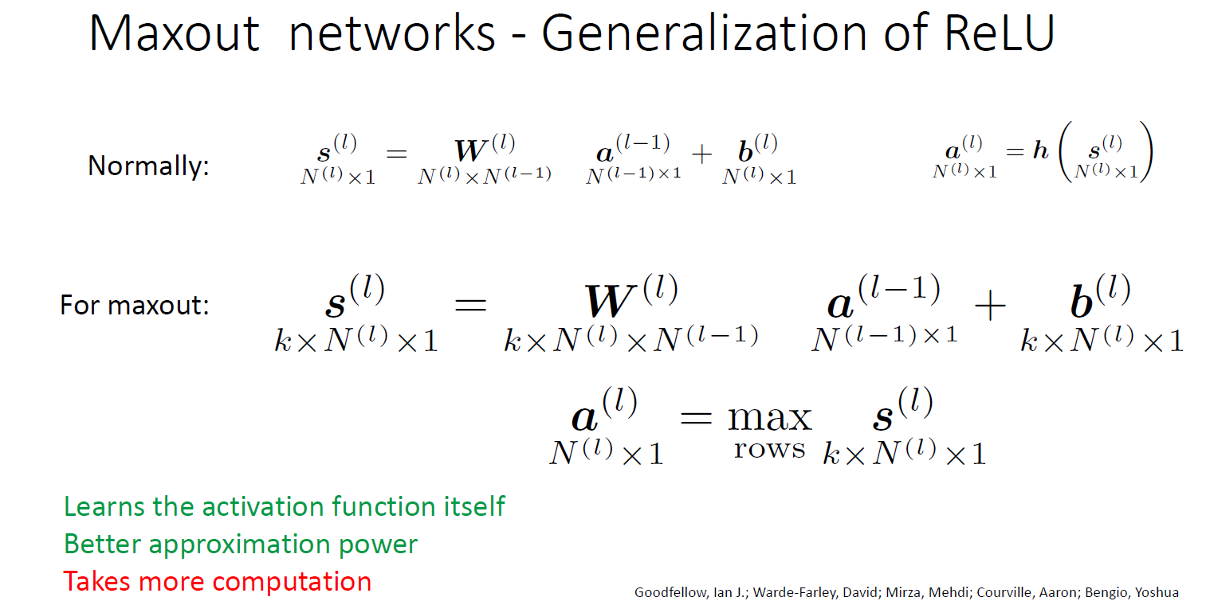

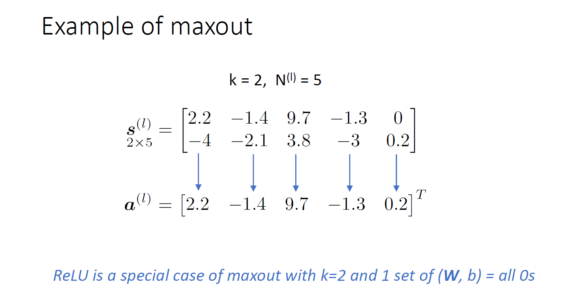

**Output Activation Function**

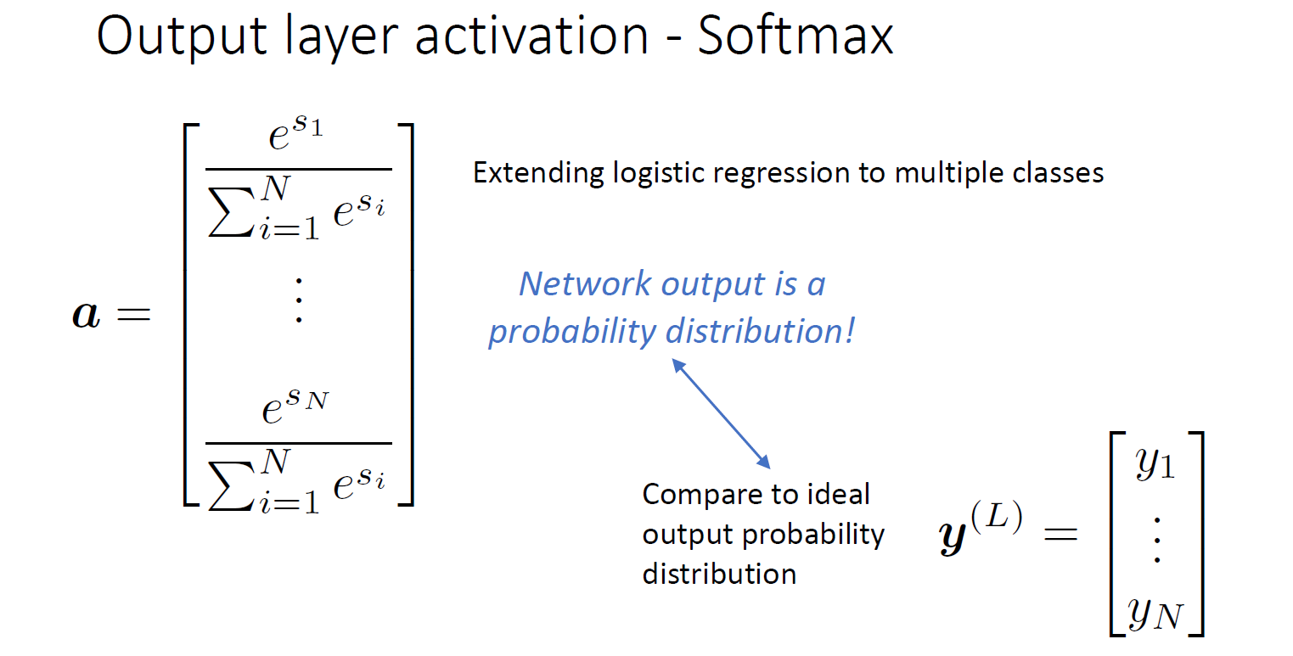

**Cost Function**

Cross-entropy Cost

One Hot label vs. Softmax

Quadratic Cost (MSE)

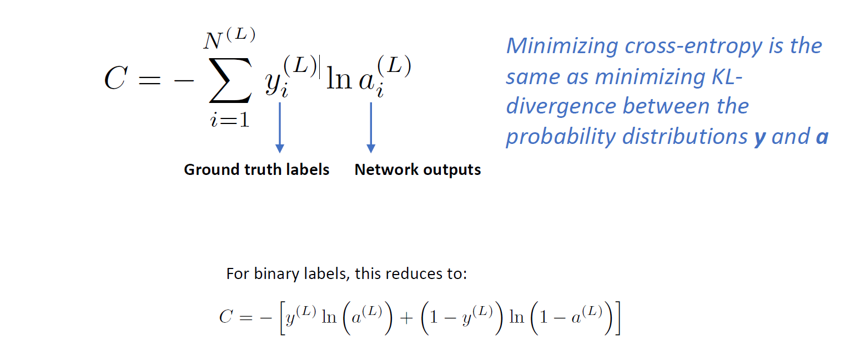

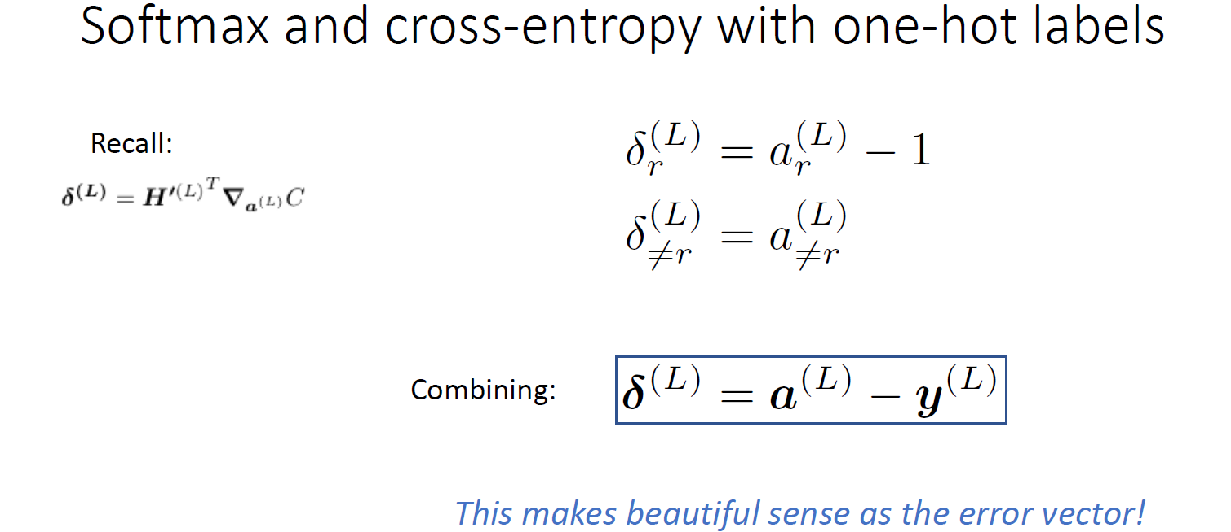

**Optimizer**

**Hessian**

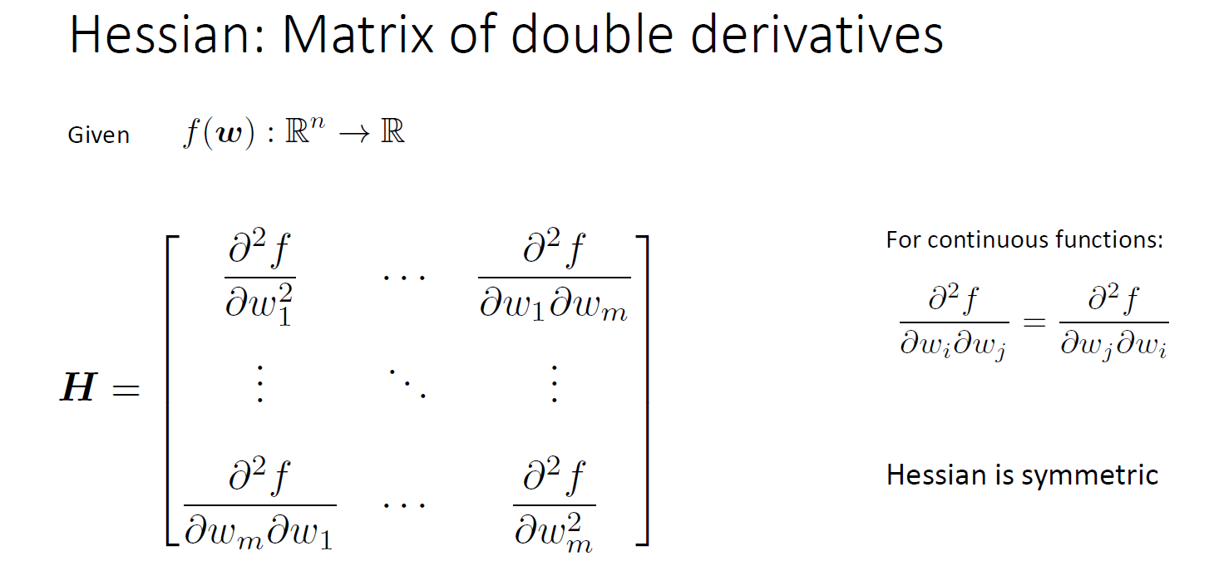

**Condition**

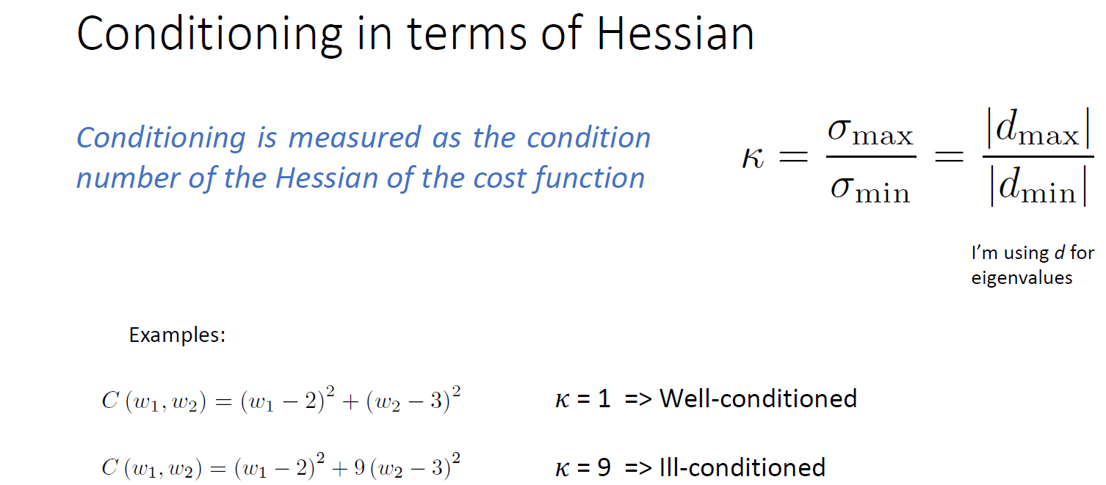

will condition lead to fast gradient

**Momentum**

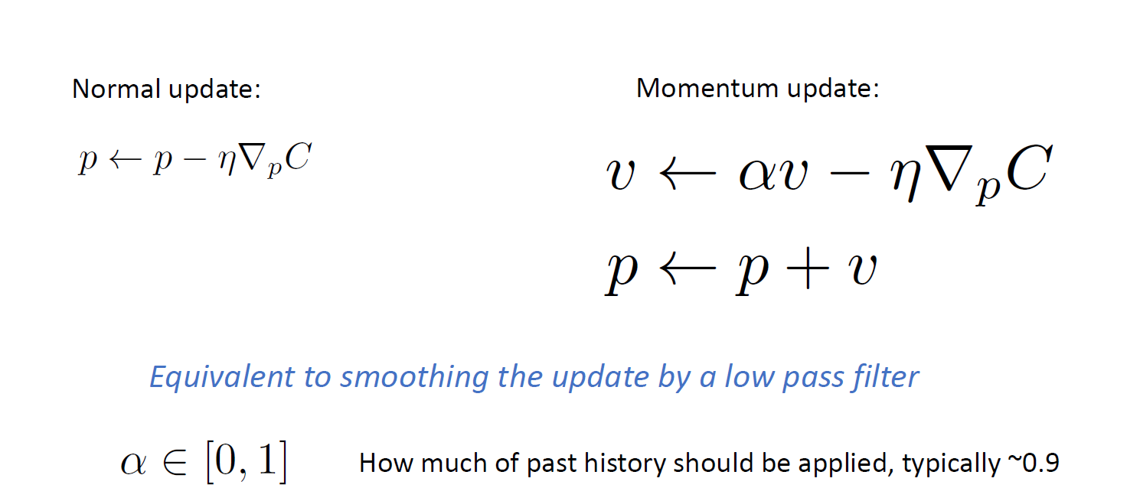

α (Momentum factor) normally i**ncrease** with the step goes

η (Learning Rate) **decrease** with step goes

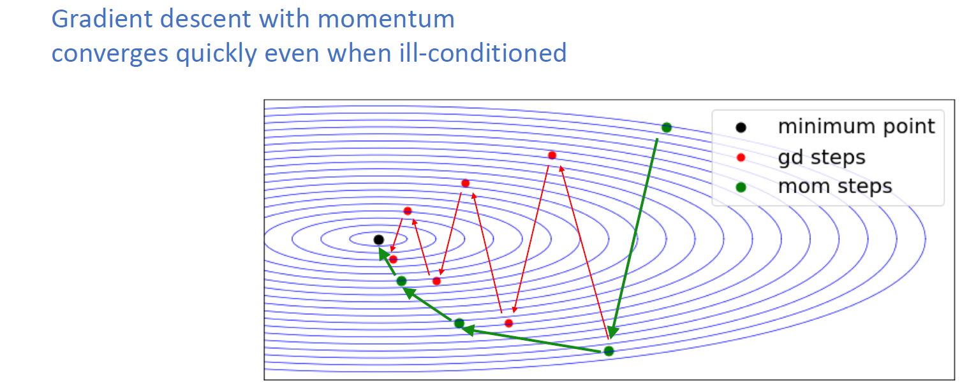

Nesterov Momentum

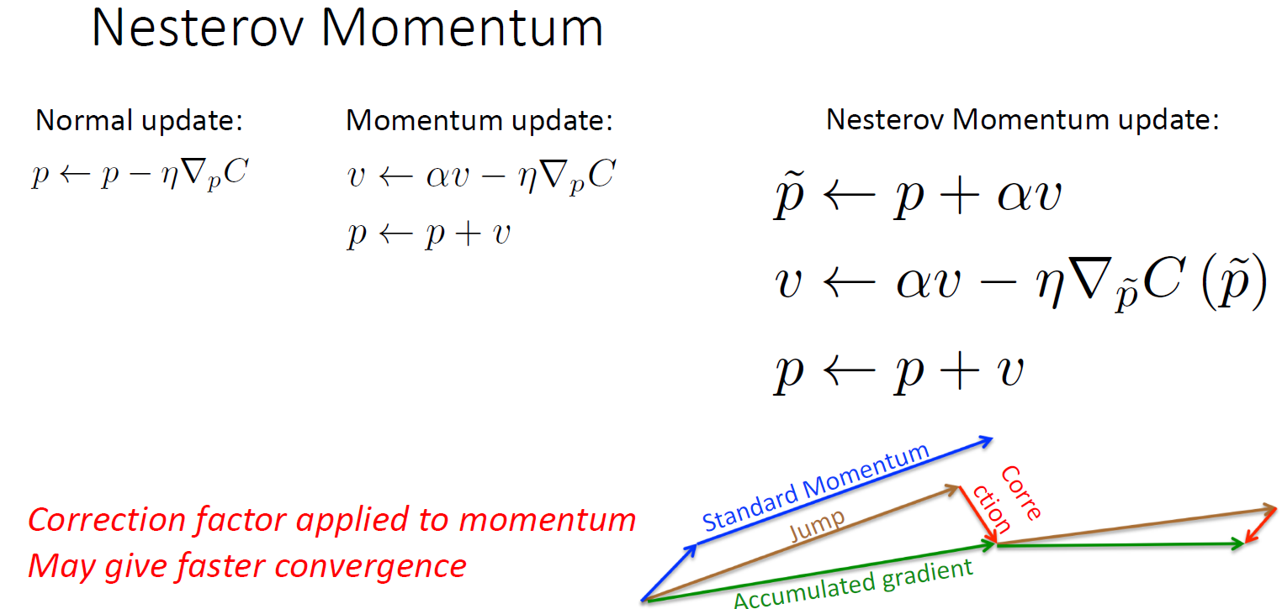

**Differenct Kinds of Optimizers**

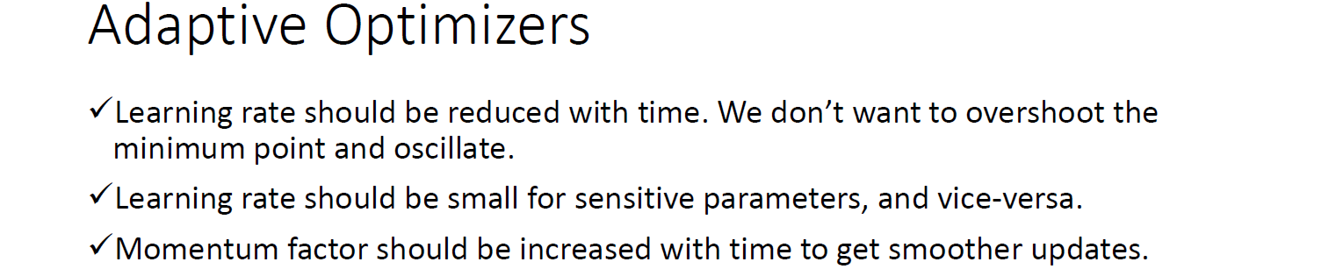





**RMSprop**

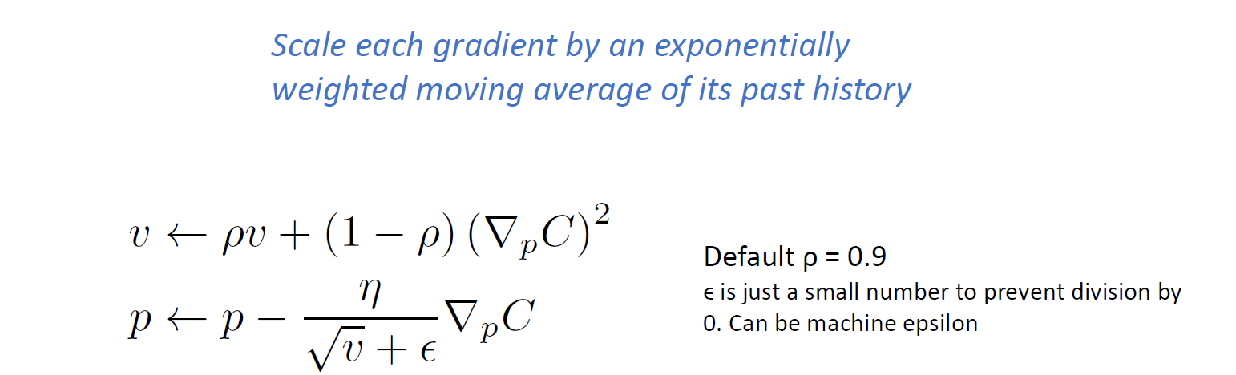

**Adam (more complex compared to RMSprop)**

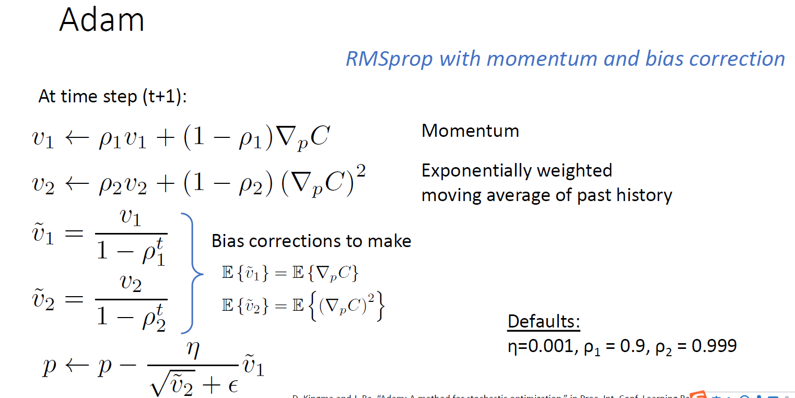

**SGD**

(may include momentum and learning rate)

more basic, need more experience

**AdaMax**

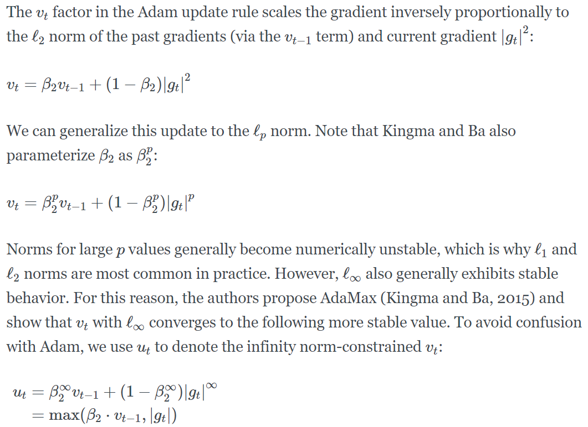

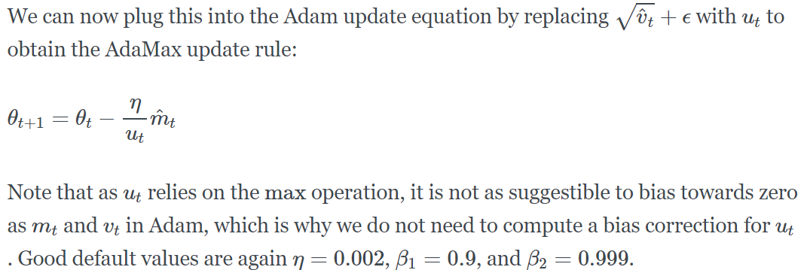

**Adadelta (fastest)**

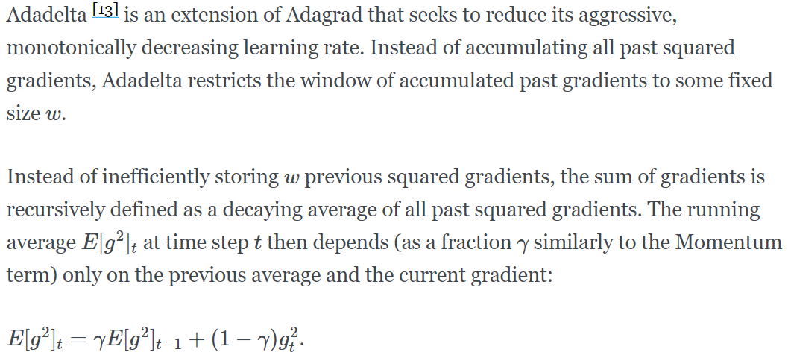

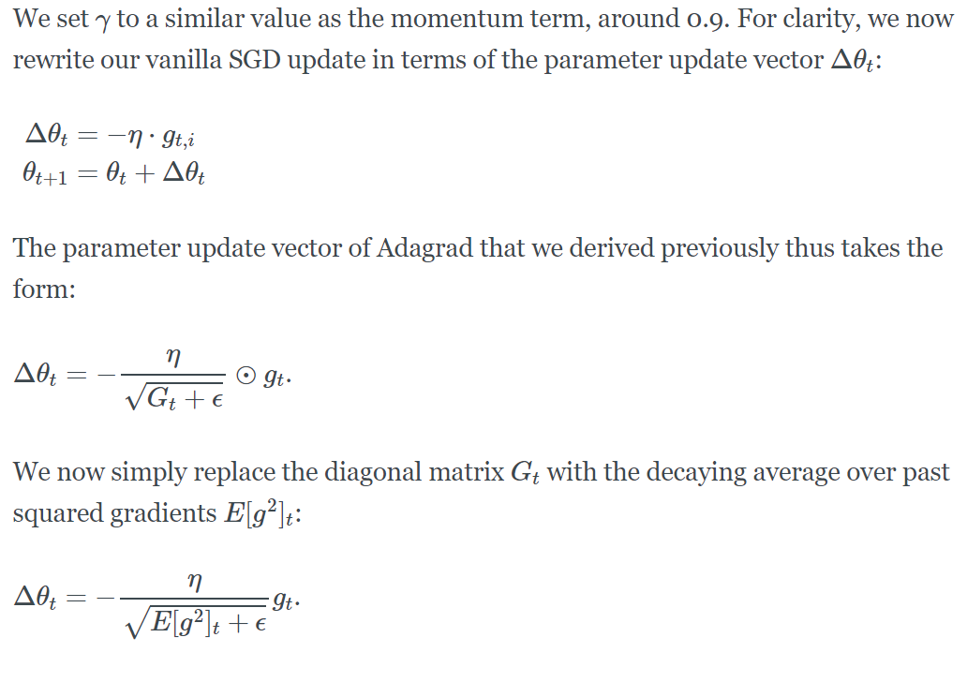

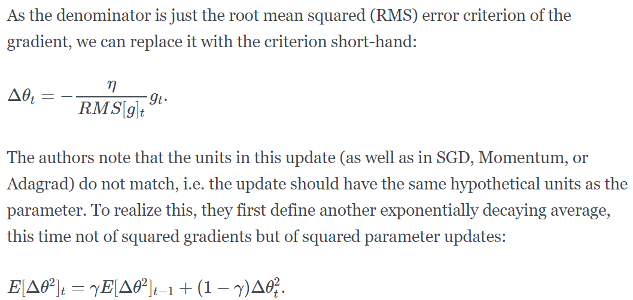

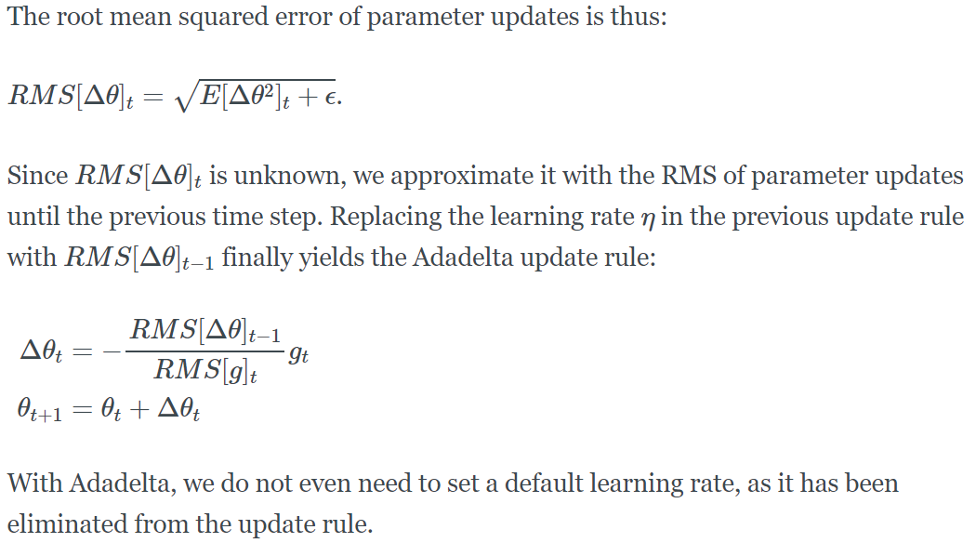

**which optimizer is best?**

**RMSprop** is an extension of Adagrad that deals with its radically diminishing learning rates. It is **identical to Adadelta**, except that Adadelta uses the RMS of parameter updates in the numinator update rule. Adam, finally, adds bias-correction and momentum to RMSprop. Insofar, **RMSprop, Adadelta**, and **Adam** are very similar algorithms that do well in similar circumstances.

**Regularization**

bias- variance trade-off (in EE660) (**for a given MSE**)

**Dropout**

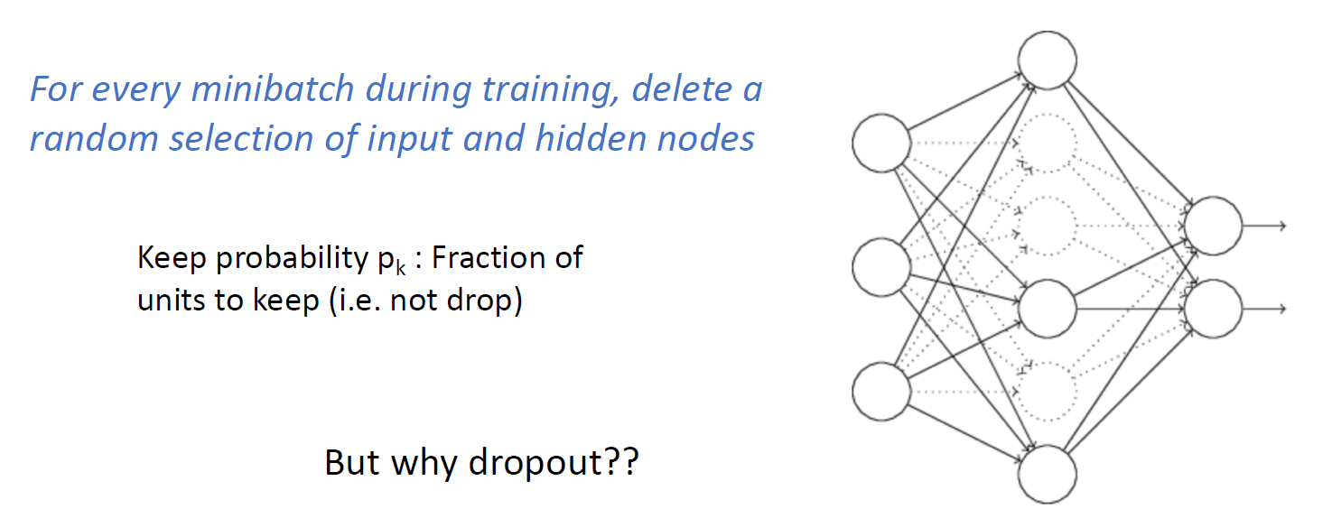

Esemble method turn to drop out

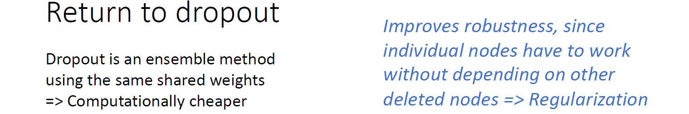

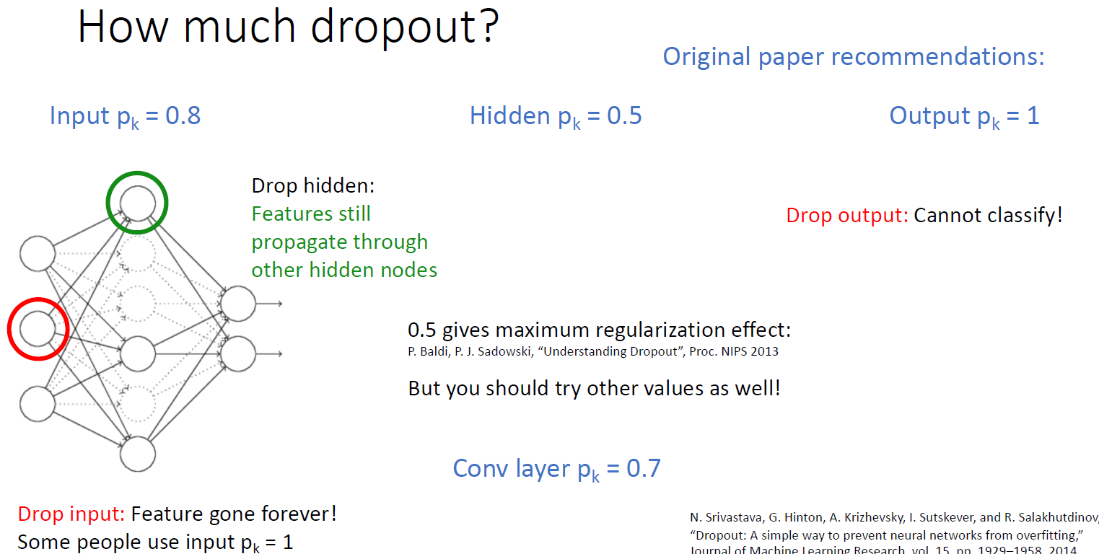

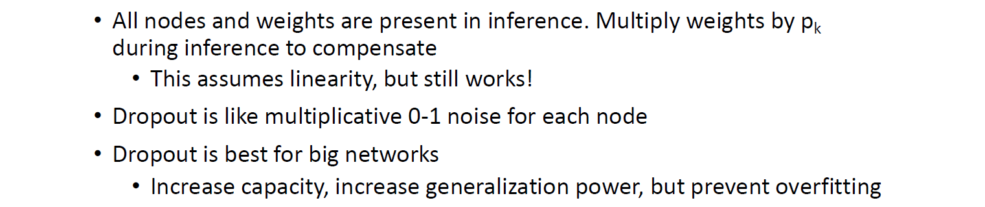

**Normalization**

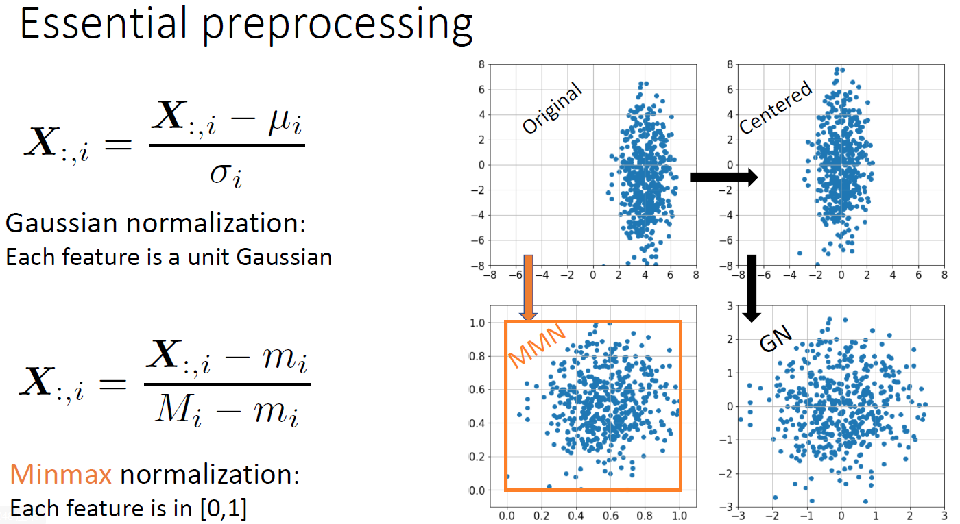

**Dimensionality Reduction**

SVD: singular value decomposition

**PCA**

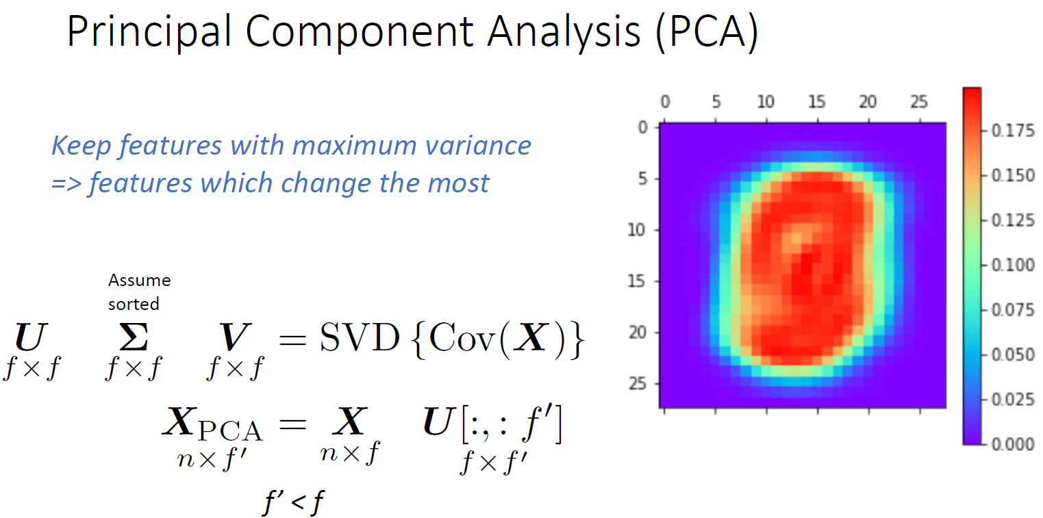

**LDA**

need labels of all data, change data based on it's label

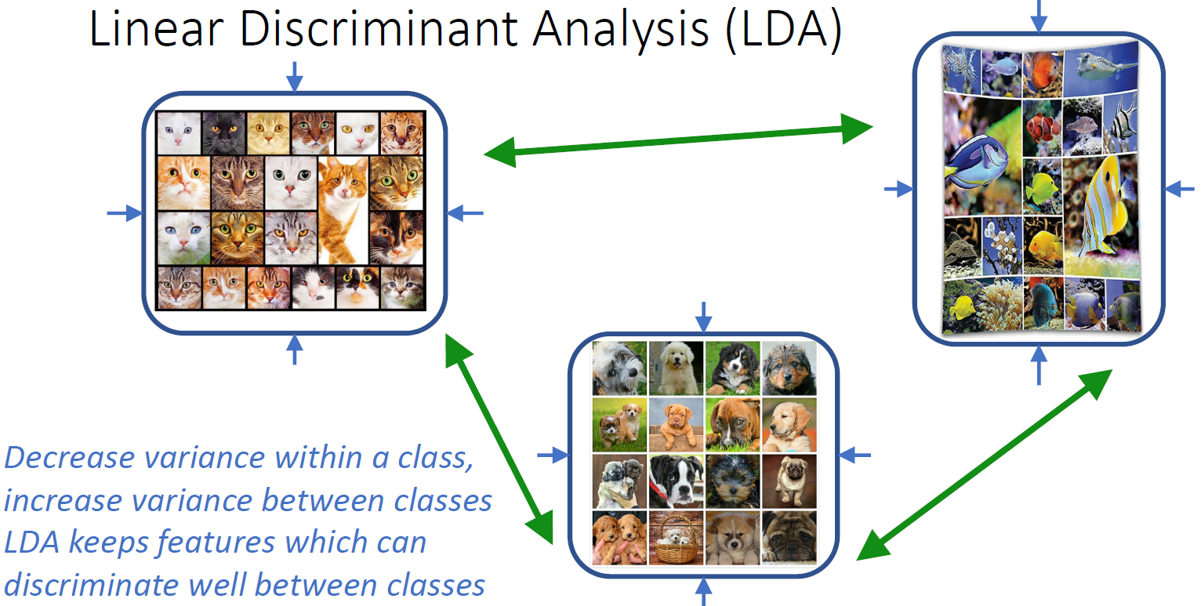

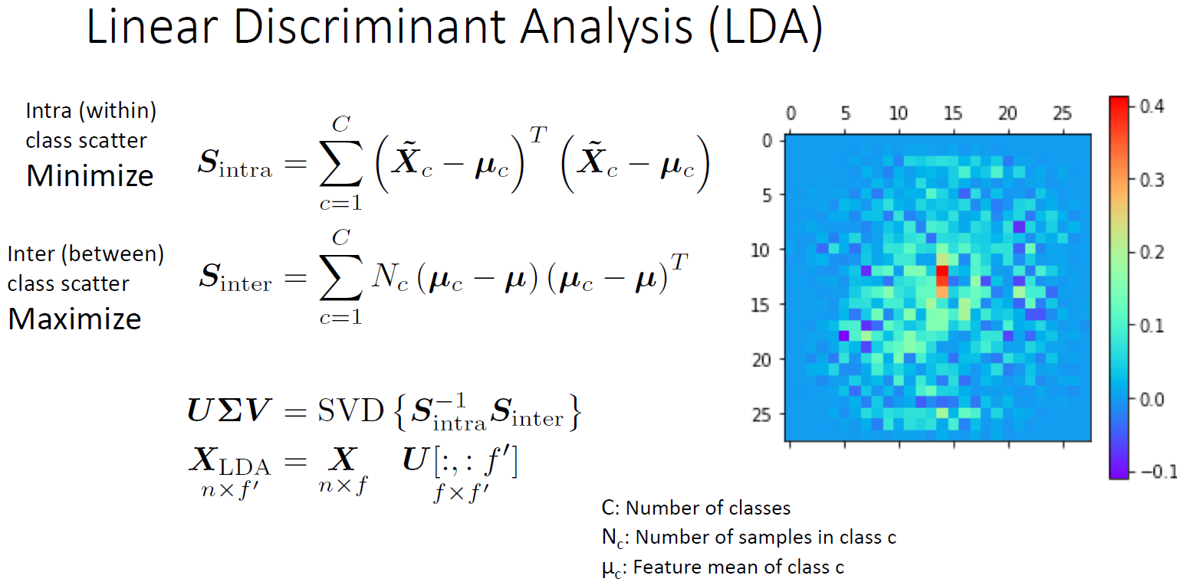

**Hyper parameter**

things Neural Network don't learning by themself

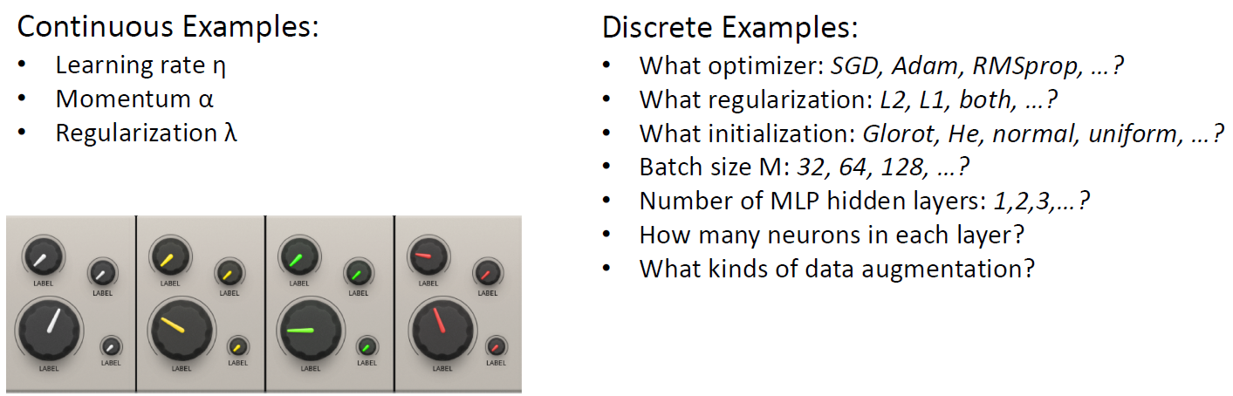

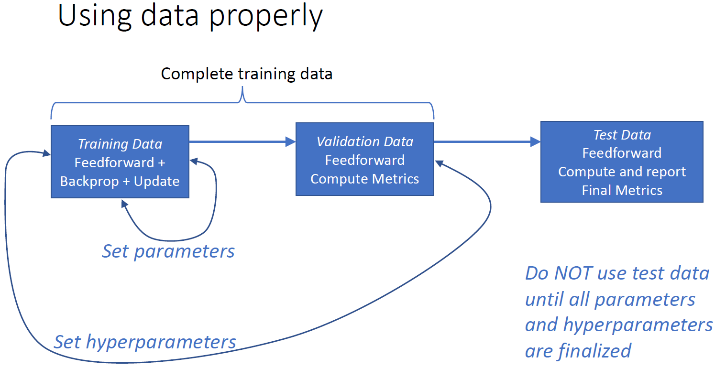

**use cross validation to set hyper-parameters**

**Hyper-parameter seatch**

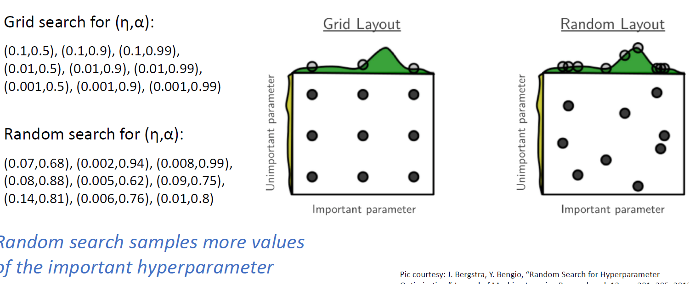

**Learning Rate Schedules**

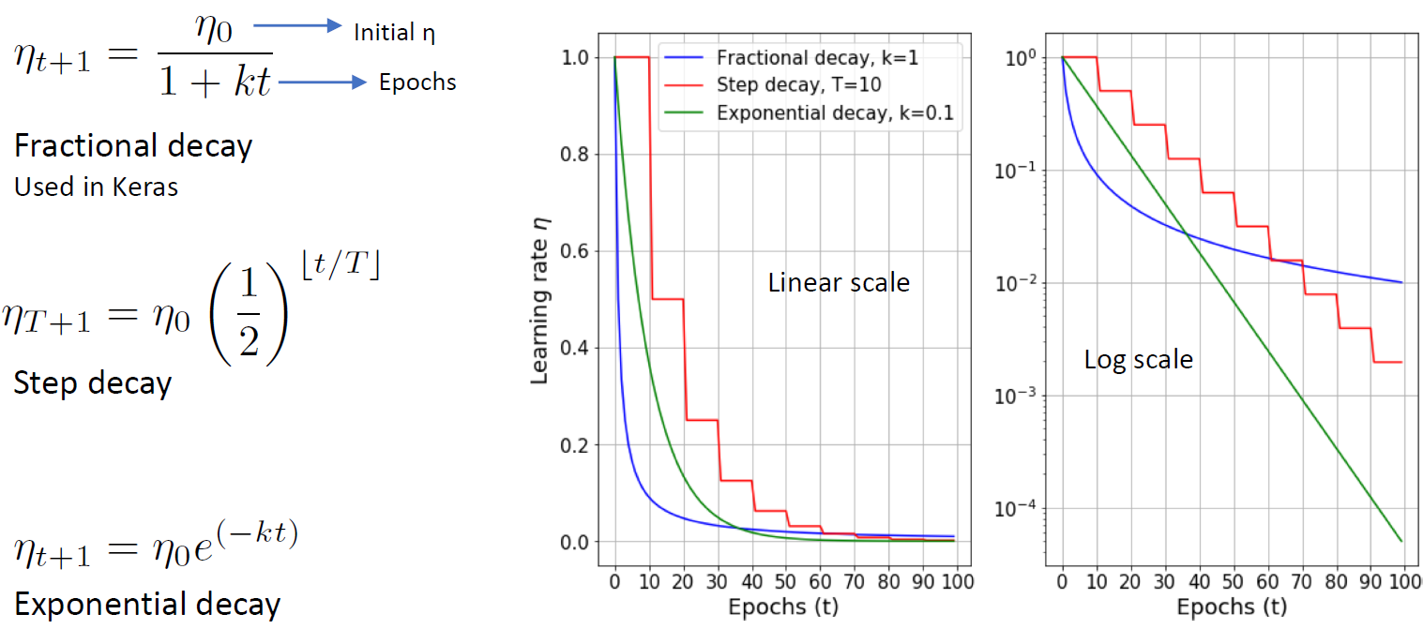

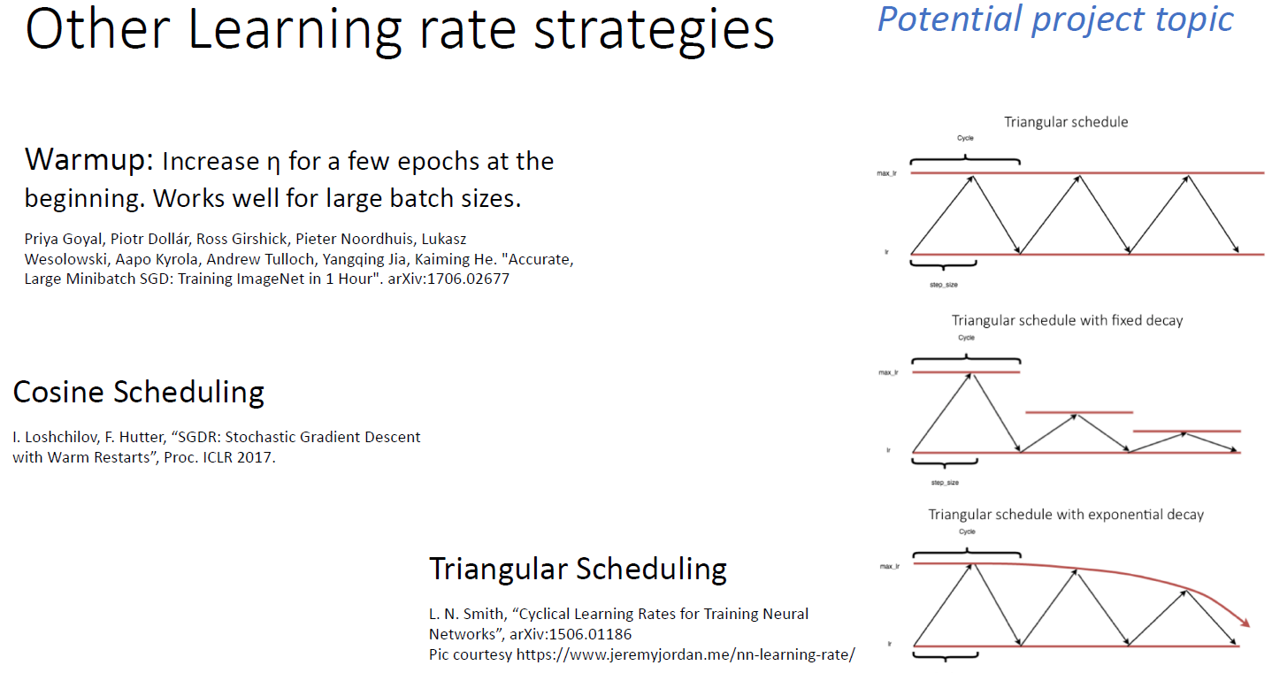

**Universal Approximation Theorem**

basic idea: Neural Network can simulate all function

<http://neuralnetworksanddeeplearning.com/chap4.html>

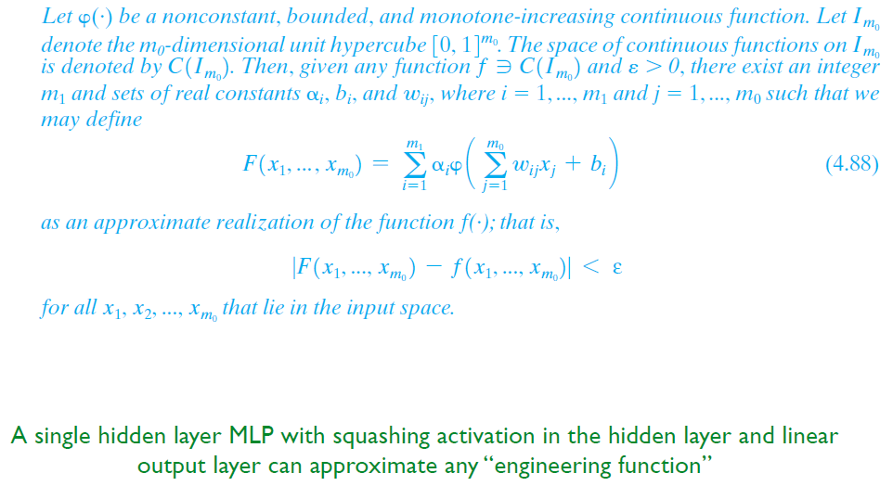

**CNN**

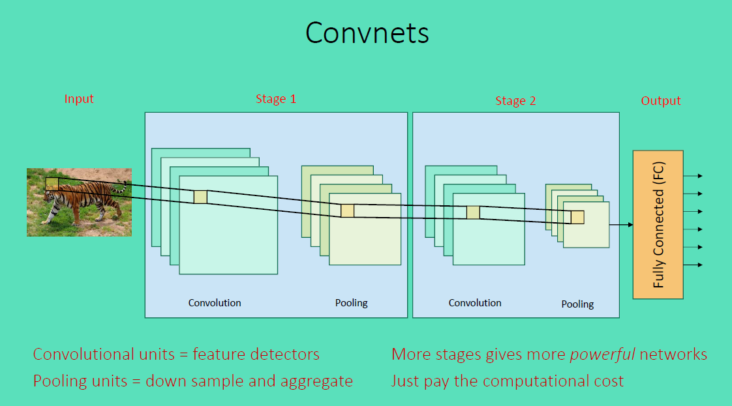

**Introduction**

good introduction: http://cs231n.github.io/convolutional-networks/#pool

In summary:

A ConvNet architecture is in the simplest case a list of Layers that transform the image volume into an output volume (e.g. holding the class scores)

There are a few distinct types of Layers (e.g. CONV/FC/RELU/POOL are by far the most popular)

Each Layer accepts an input 3D volume and transforms it to an output 3D volume through a differentiable function

Each Layer may or may not have parameters (e.g. CONV/FC do, RELU/POOL don’t)

Each Layer may or may not have additional hyperparameters (e.g. CONV/FC/POOL do, RELU doesn’t)

**Kernel(Filter)**

Slide

Padding

**size:**

small (3*3) deep

large (5*5) fast reduction,shallow, more parameters

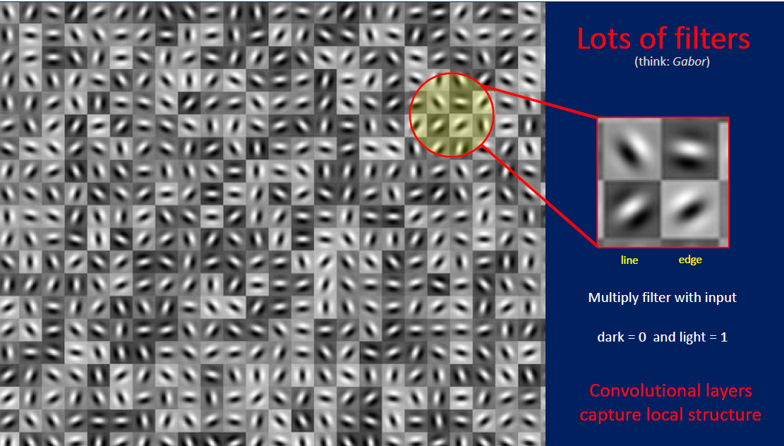

**Conv layer**

image: 3-D in volume

**basic:** each neural is only connect to some of the neural in next layer

**Basic Function of Conv-layer:**

also like Σ(wx)+b (if **b** exist?)

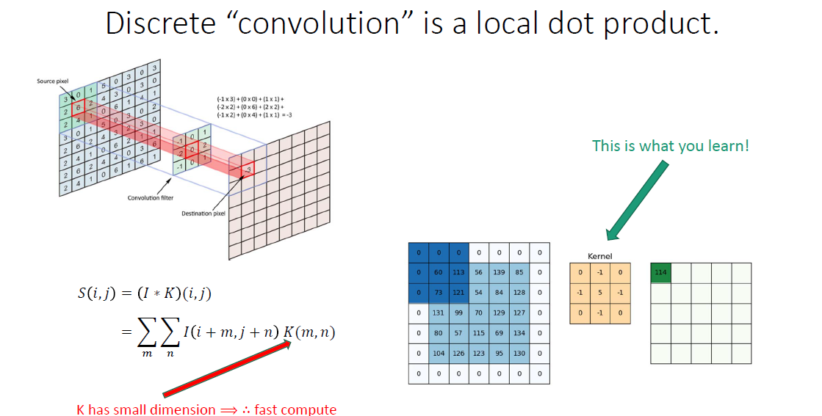

use dot production to compute kernel* cut part

Intuitively, the network will learn filters that activate when they see some type of visual feature such as an edge of some orientation or a blotch of some color on the first layer, or eventually entire honeycomb or wheel-like patterns on higher layers of the network.

**Hyper-Parameters**

**depth**

number of filters we want to use, they will look into the same region

**stride**

commonly--> 1

**zero-padding**

we could:

1. control the output volume size

2. remain the edge information

**For three channel**

three filters to combine a kernel, three output add up together, and add bias







**dilation**

it’s possible to have filters that have spaces between each cell, called dilation.

in one dimension a filter w of size 3 would compute over input x the following: w[0]*x[0] + w[1]*x[1] + w[2]*x[2]. This is dilation of 0. For dilation 1 the filter would instead compute w[0]*x[0] + w[1]*x[2] + w[2]*x[4]

so the computed block is not continous

**compute output size(O)**

by input size(**W**), filter size(**F**) and stride(**S**) and amount of zero padding(**P**)

O=(W−F+2P)/S+1.

input W*W output O*O

**Parameter Sharing(weight sharing)**

one feature is useful to compute at some spatial position (x,y), then it should also be useful to compute at a different position (x2,y2). In other words, denoting a single 2-dimensional slice of depth as a **depth slice**

we are going to constrain the neurons in each depth slice to use the same weights and bias

for example: for a 11*11 kernel in RGB with 96 filters

there are 96*11*11*3+96 = 34944 parameters in totally

 all 55*55 neurons in each depth slice will now be using the same parameters.

questions? each filter has three channel or just one?

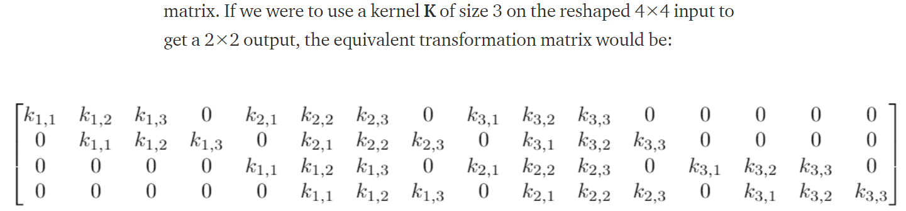

**a new method: seperable convolution**

**Xception**

convert 3*3 kernel to 3*1 and 1*3 (used in Enmedded system)

**Pooling layer**

  Its function is to progressively reduce the spatial size of the representation to **reduce the amount of parameters and computation in the network**, and hence to also control overfitting.

Max pooling | average pooling | L2-norm pooling

**Extents-->** # of points pooling together

**Stride -->** # of step to move in next pooling

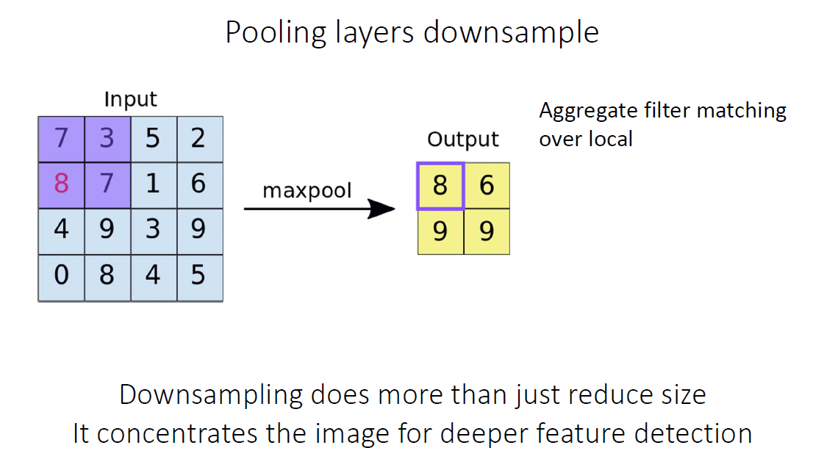

**De-Conv(Transpose convolution) layer**

convolution: a pixels block into a point --> down sampling

de-convolution: a point to a block --> up sampling, from a low resolution to a higher one

use one point in the previous layer to generate 3*3 blocks with the help of filter

For an example in the image below, we apply transposed convolution with a 3 x 3 kernel over a 2 x 2 input padded with a 2 x 2 border of zeros using unit strides. The up-sampled output is with size 4 x 4.



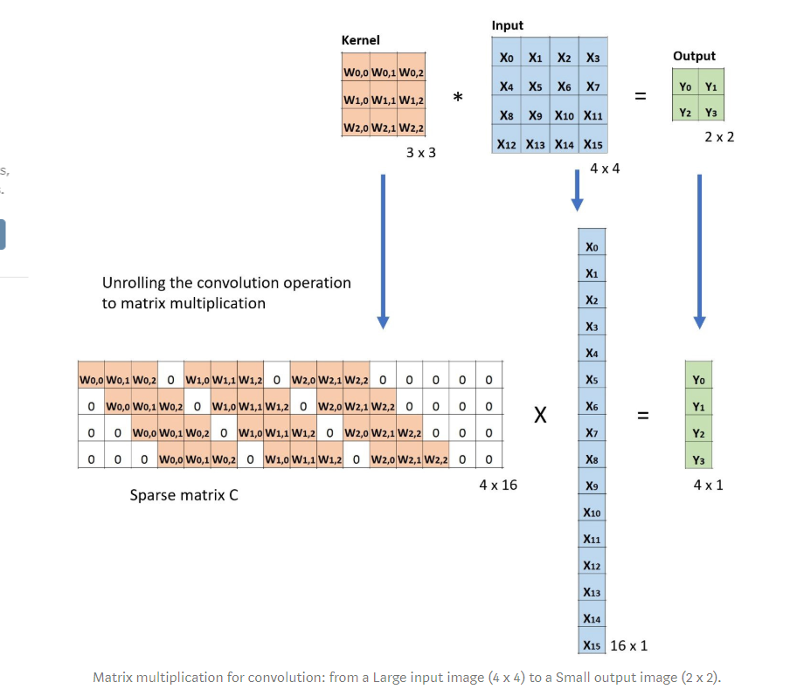

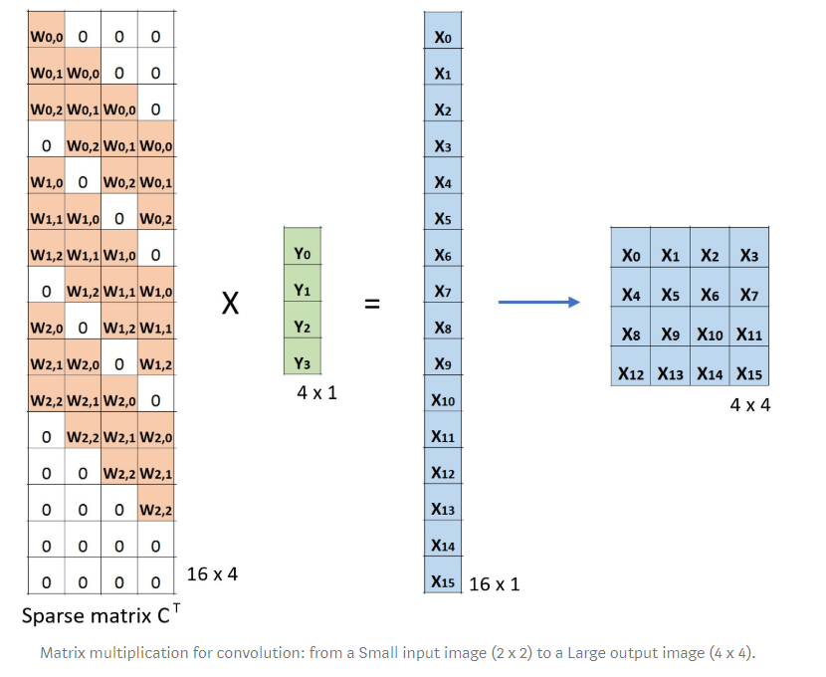

map e.g. 4-dimensional space to 25-dimensional space



Transposed 2D convolution with no padding, stride of 2 and kernel of 3

**Group Convolution**

In each filter group, the depth of each filter is only half of the that in the nominal 2D convolutions. They are of depth Din / 2. Each filter group contains Dout /2 filters. The first filter group (red) convolves with the first half of the input layer ([:, :, 0:Din/2]), while the second filter group (blue) convolves with the second half of the input layer ([:, :, Din/2:Din]). As a result, each filter group creates Dout/2 channels. Overall, two groups create 2 x Dout/2 = Dout channels. We then stack these channels in the output layer with Dout channels.

**Advantage:**

efficient training.

model is more efficient

Grouped convolution may provide a better model than a nominal 2D convolution.

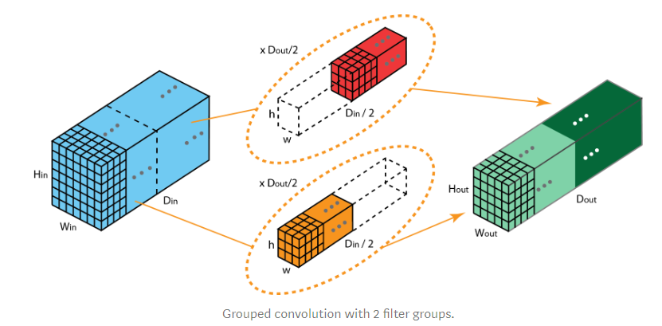

**this is a bit similar like seperable convolutions**

If the number of filter groups is the same as the input layer channel, each filter is of depth Din / Din = 1. This is the same filter depth as in depthwise convolution.

**Seperable Convolutions**

Efficiency!

in **MobileNet:** <https://arxiv.org/pdf/1704.04861.pdf>

change the 3*3 kernel to 3*1 and 1*3 two kernel This would require 6 instead of 9 parameters while doing the same operations.

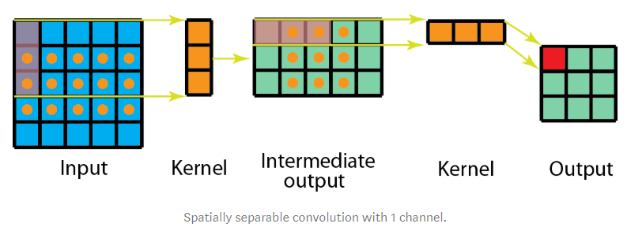

Although spatially separable convolutions save cost, it is rarely used in deep learning. One of the main reason is that not all kernels can be divided into two, smaller kernels. If we replace all traditional convolutions by the spatially separable convolution, we limit ourselves for searching all possible kernels during training. The training results may be sub-optimal.

**Depthwise Separable Convolutions**

much commonly used in deep learning: **depthwise convolution** and **1*1 convolution**

First, we apply **depthwise convolution** to the input layer. Instead of using a single filter of size 3 x 3 x 3 in 2D convolution, we used **3 kernels**, **separately.** Each filter has size **3 x 3 x 1**. Each kernel convolves with 1 channel of the input layer (1 channel only, not all channels!). We then stack these maps together to create a 5 x 5 x 3 image. After this, we have the output with size 5 x 5 x 3.

As the second step of depthwise separable convolution, to extend the depth, we apply the 1x1 convolution with kernel size 1x1x3. Convolving the 5 x 5 x 3 input image with each 1 x 1 x 3 kernel provides a map of size 5 x 5 x 1.

Thus, after applying 128 1x1 convolutions, we can have a layer with size 5 x 5 x 128.

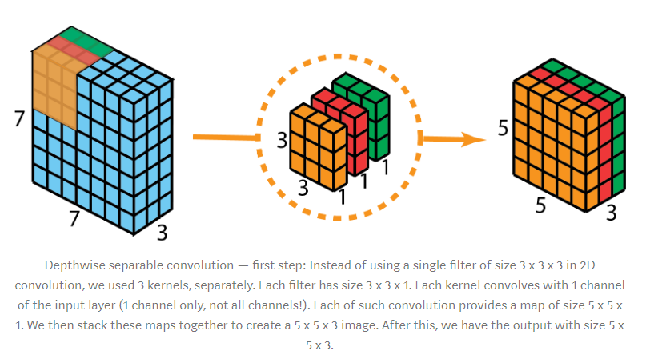

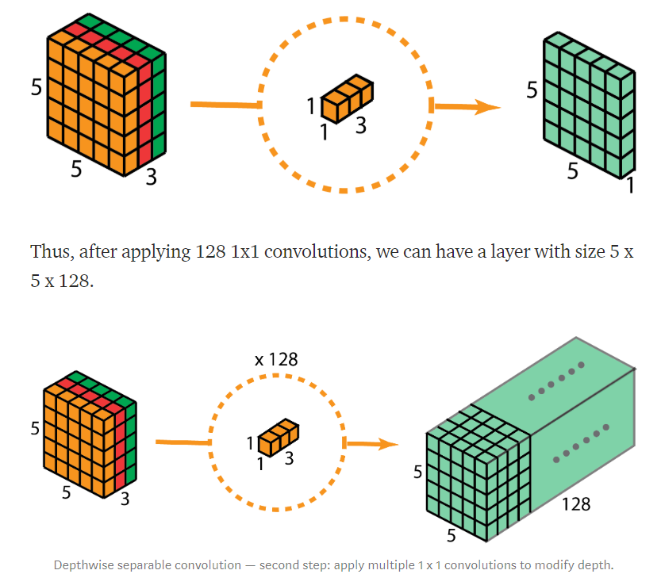

**drwaback:**

reduces the number of parameters in the convolution. As such, for a small model, the model capacity may be decreased significantly if the 2D convolutions are replaced by depthwise separable convolutions.

**Full Connect layer**

**# of Parameters computation**

**Visualization**

 layers that are deeper in the network visualize more training data specific features, while the earlier layers tend to visualize general patterns like edges, texture, background

**Visualize different layer**

**Visualize filter**

**Heatmap**

**Different Nets**

**LeNet(1998)**

classifies digits in 32x32 pixel greyscale inputimages

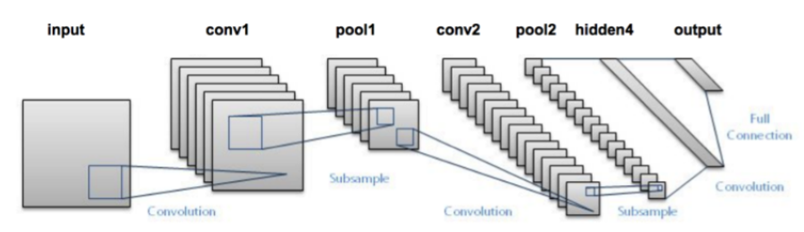

**AlexNet(2012)**

  deeper, with more filters per layer, and with stacked convolutional layers. It consisted 11x11, 5x5,3x3, convolutions, max pooling, dropout, data augmentation, ReLU activations, SGD with momentum.

train on two GPUs

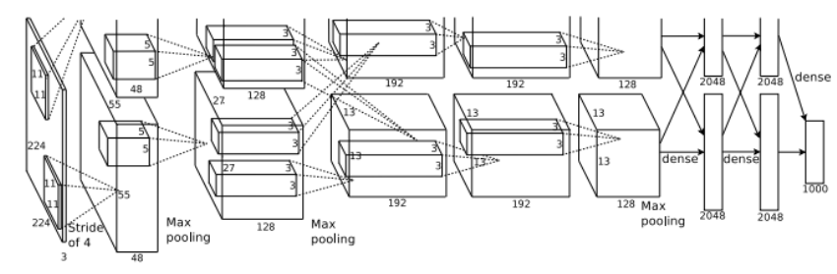

**VGG**

<https://arxiv.org/pdf/1409.1556.pdf>

Baseline feature extractor

16 (weighted) layers CNN 138M parameters

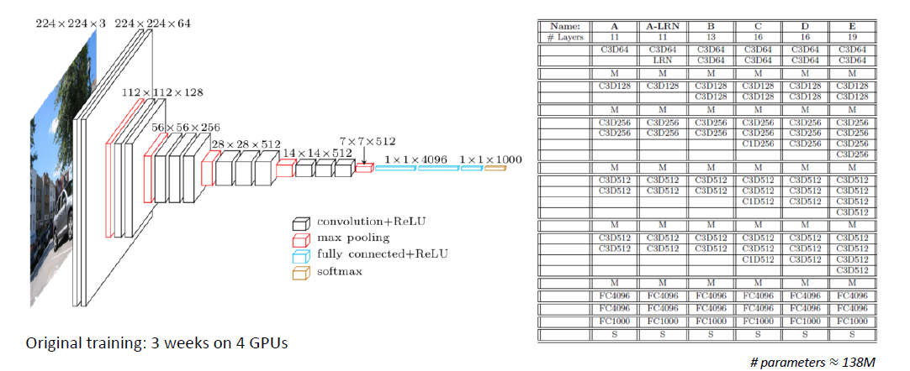

**Resnet**

gated recurrent units

take a standard feed-forward ConvNet and add **skip connections** that bypass (or shortcut) a few convolution layers at a time. Each bypass gives rise to a residual block in which the convolution layers predict a residual that is added to the block’s input tensor.

aim to avoid vanish gradient

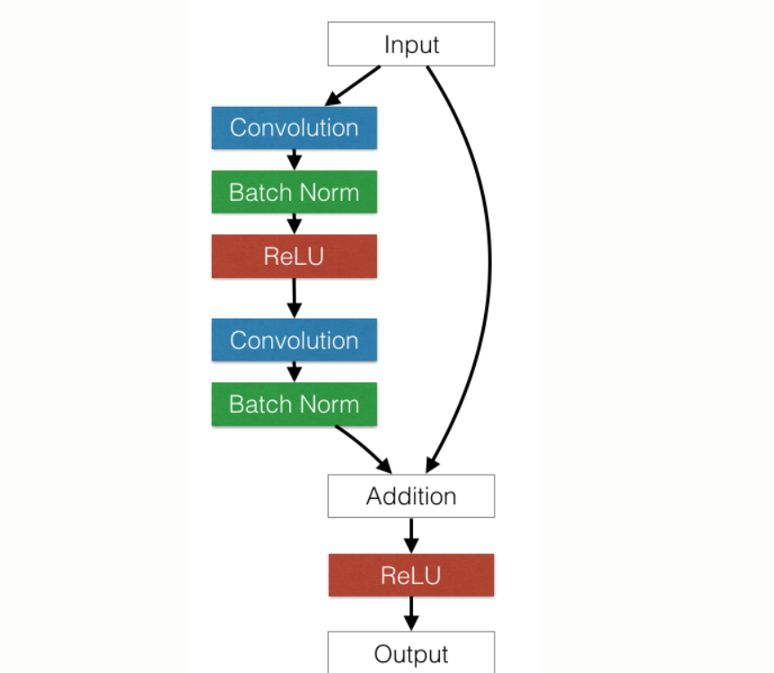

**GoogleNet (Inception)**

<https://arxiv.org/pdf/1512.00567.pdf>

<https://arxiv.org/pdf/1409.4842.pdf>

no Pooling layer

**Introduction**

The network used a CNN inspired by LeNet but implemented a novel element which is dubbed an inception module. It used batch normalization, image distortions and RMSprop. This module is based on several very small convolutions in order to drastically reduce the number of parameters. Their architecture consisted of a 22 layer deep CNN but reduced the number of parameters from 60 million (AlexNet) to 4 million.

**Speciality**

1. use several small filter to stand large filter --> n*1 + 1*n to replace n*n

2. for a single input layer, applied many different filters(some are pooling, some are 1*1 with 1*n with n*1) and concatedate result (add together)

---> **to avoid representational bottlenecks and avoid stop locally**

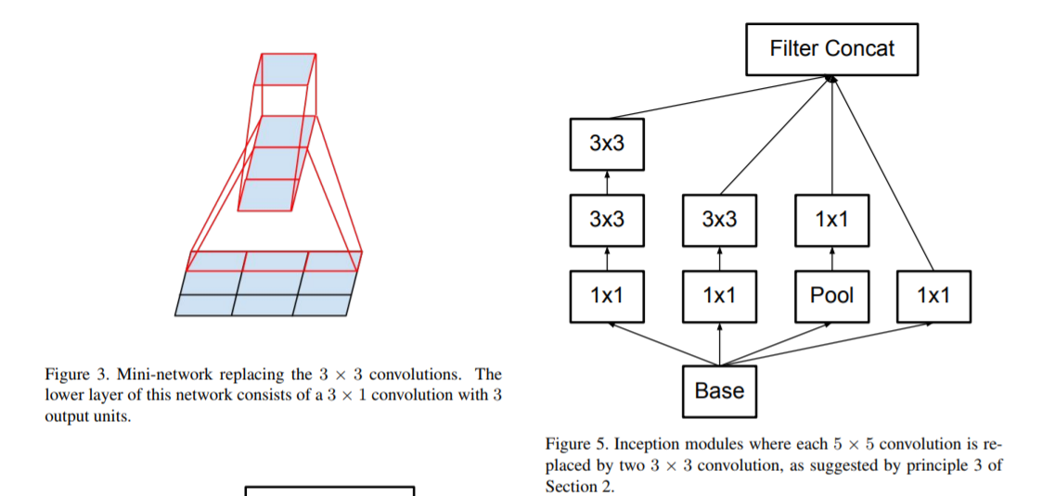

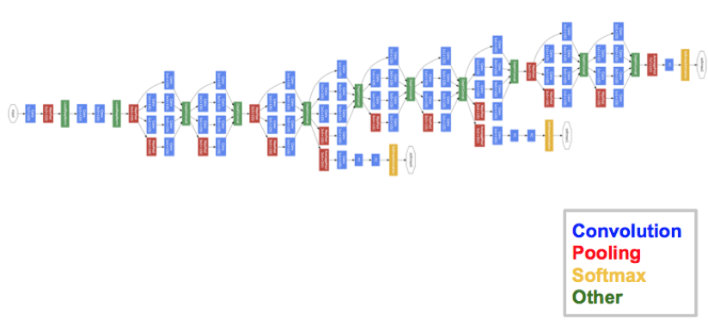

**MobileNet**

<https://arxiv.org/pdf/1704.04861.pdf>

Deepwise Seperable Convolution + Pointwise Convolution (1*1)

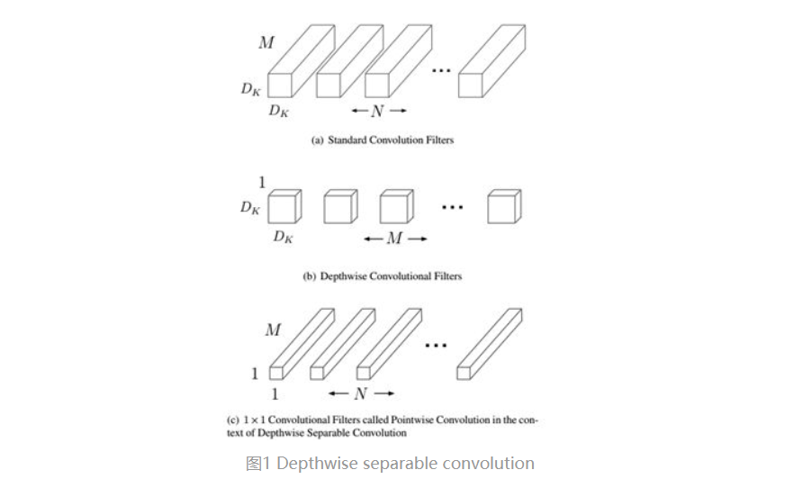

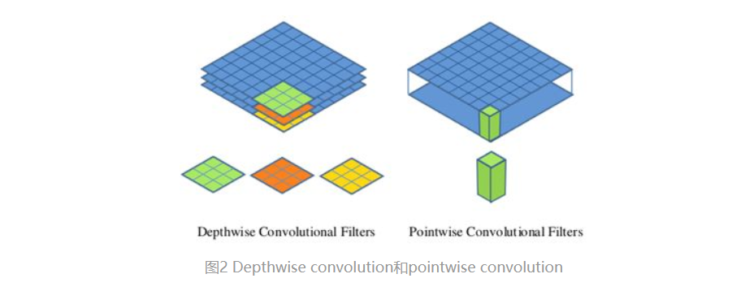

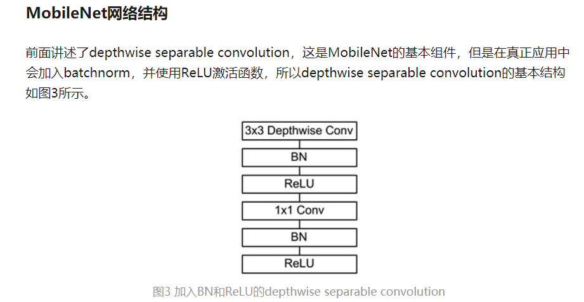

MobileNet的网络结构如表1所示。首先是一个3x3的标准卷积，然后后面就是堆积depthwise separable convolution，并且可以看到其中的部分depthwise convolution会通过strides=2进行down sampling。然后采用average pooling将feature变成1x1，根据预测类别大小加上全连接层，最后是一个softmax层。如果单独计算depthwise

convolution和pointwise convolution，整个网络有28层（这里Avg Pool和Softmax不计算在内）。我们还可以分析整个网络的参数和计算量分布，如表2所示。可以看到整个计算量基本集中在1x1卷积上，如果你熟悉卷积底层实现的话，你应该知道卷积一般通过一种im2col方式实现，其需要内存重组，但是当卷积核为1x1时，其实就不需要这种操作了，底层可以有更快的实现。对于参数也主要集中在1x1卷积，除此之外还有就是全连接层占了一部分参数。



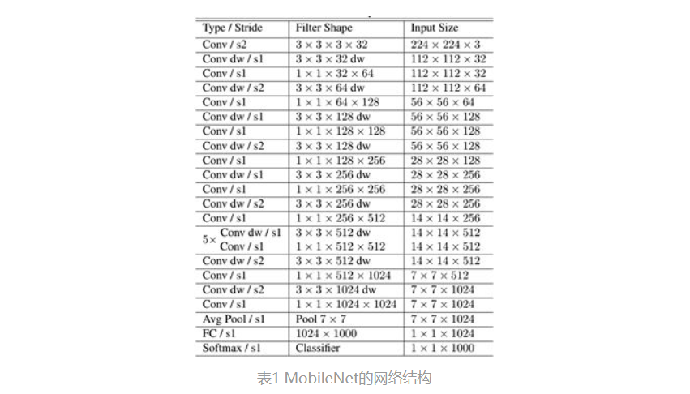

**Comparation**

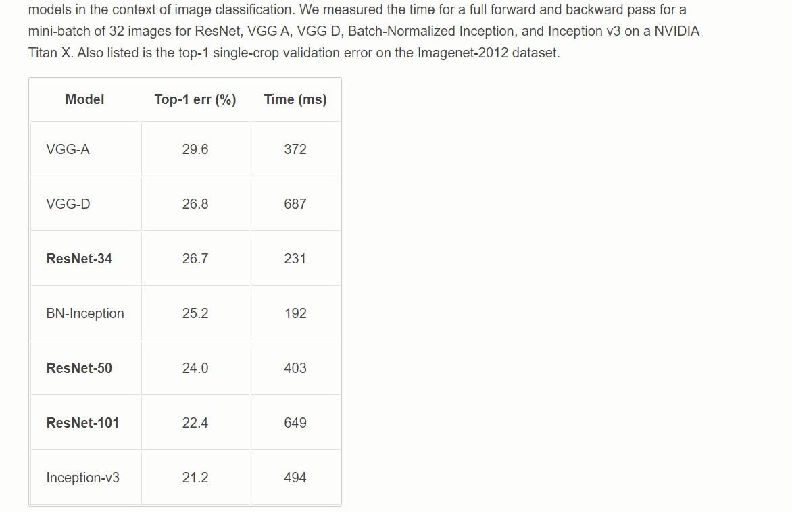

**CNN in NLP**

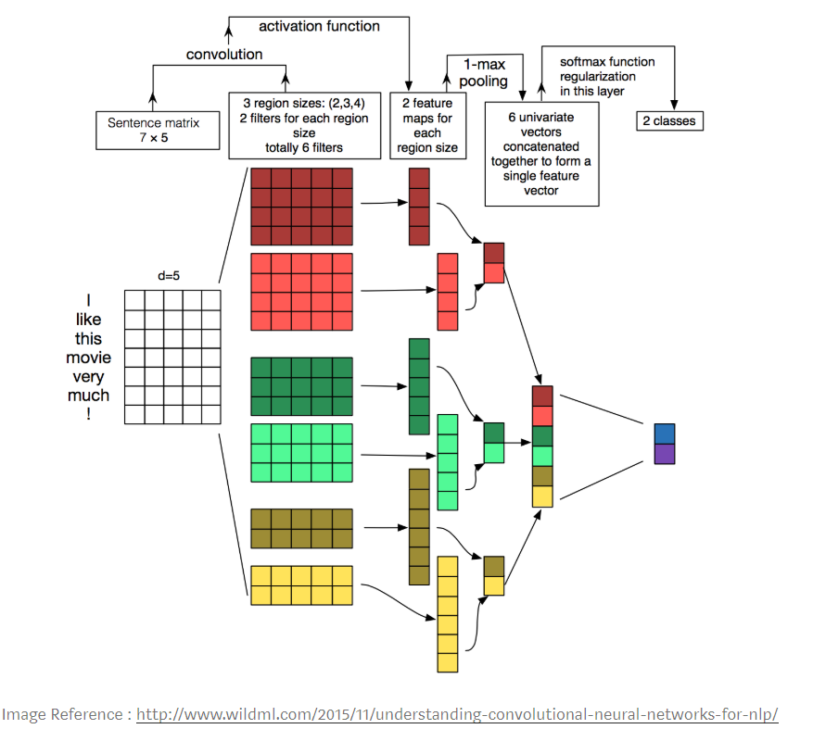

**Coding**

**Keras**

a basic model

from keras.models import Sequential
from keras.layers import Dense, Conv2D, Flatten#create model
model = Sequential()#add model layers
model.add(Conv2D(64, kernel_size=3, activation=’relu’, input_shape=(28,28,1)))
model.add(Conv2D(32, kernel_size=3, activation=’relu’))
model.add(Flatten())
model.add(Dense(10, activation=’softmax’))
# Compiling the model takes three parameters: optimizer, loss and metrics.
model.compile(optimizer='adam', loss='categorical_crossentropy', metrics=['accuracy'])
#train the model
model.fit(X_train, y_train, validation_data=(X_test, y_test), epochs=3)
#predict first 4 images in the test set
model.predict(X_test[:4])
model = Sequential()
model.add(Conv2D(32, (3, 3), padding='same',
input_shape=x_train.shape[1:]))
model.add(Activation('relu'))
model.add(Conv2D(32, (3, 3)))
model.add(Activation('relu'))
model.add(MaxPooling2D(pool_size=(2, 2)))
model.add(Dropout(0.25))
model.add(Conv2D(64, (3, 3), padding='same'))
model.add(Activation('relu'))
model.add(Conv2D(64, (3, 3)))
model.add(Activation('relu'))
model.add(MaxPooling2D(pool_size=(2, 2)))
model.add(Dropout(0.25))
model.add(Flatten())
model.add(Dense(512))
model.add(Activation('relu'))
model.add(Dropout(0.5))
model.add(Dense(num_classes))
model.add(Activation('softmax'))

  **‘Flatten’ layer.** Flatten serves as a connection between the convolution and dense layers.

**RNN**

**Word Embedding**

**BERT**

BERT (Bidirectional Encoder Representations from Transformers), released in late 2018, is a method to **pretrain language representations** that was used to create models that NLP practicioners can then download and use for free. You can either use these models to extract high quality language features from your text data, or you can fine-tune these models on a specific task (classification, entity recognition, question answering, etc.) with your own data to produce state of the art predictions.

**TensorFlow and Keras**

**sequential model**

**Pytorch**